Earth Science Subcommittee Report
August 28, 2015 Meeting
Via Teleconference

From: The NASA Earth Science Subcommittee – Steven W. Running (Chair, swr@ntsg.umt.edu), Roland Burgmann, Greg Carmichael, Andrew Dressler, Efi Foufoula-Georgiou, S. Prasad Gogineni, Kathleen Green, Thomas Herring, Ian Joughin, Chris Kummerow, William Large, Patrick McCormick, Anna Michalak, Mahta Moghaddam, Anne Nolin, Richard B. Rood, Raymond W. Schmitt, J. Marshall Shephard, Herman H. (Hank) Shugart, Jr. and David A. Siegel

To: Dr. Brad Peterson (Chair, NAC Science Committee)

Cc: Elaine Denning (NAC Science Committee Executive Secretary), Lucia Tsaoussi (Earth Science Subcommittee Executive Secretary), Michael Freilich (ESD Director), Peg Luce (ESD Deputy Director), Jack Kaye (ESD Associate Director for Research), Steven Neeck (Acting ESD Associate Director for Flight Program), Lawrence Friedl (Associate Director for Applied Sciences).

Date: April 1, 2016

Dear Dr. Peterson:

The Earth Science subcommittee met on August 28, 2015 by teleconference to do the annual performance review (APR) of the Earth Science Division as required by the Government Performance and Results Act Modernization Act (GPRAMA). The Science Mission Directorate (SMD) criteria for GPRAMA voting are as follows:
• Green – Expectations for the research program fully met in context of resources invested.
• Yellow – Some notable or significant shortfalls, but some worthy scientific advancements achieved.
• Red – Major disappointments or shortfalls in scientific outcomes, uncompensated by other unusually positive results.

ESD Science Annual Performance Indicators are related to the following six Focus Areas, Atmospheric composition, Weather, Carbon Cycle, Water Cycle, Climate, and Earth Surface & Interior.

After reviewing and discussing pertinent documentation every API was unanimously voted Green, indicating that the committee found science objectives fully met for 2015. Some suggestions were made for better formatting of the report next year. However, this has been a very good year for Earth Science at NASA and the Earth Science subcommittee is very pleased with the progress and trajectory of the Earth Science Division.

I am appending the ESD GPRA 2015 annual report for background and details of our deliberations.

Our committee met at NASA Hq October 28-29, 2015, for which you have received that report. The next committee meeting is planned for Summer 2016.
Sincerely,
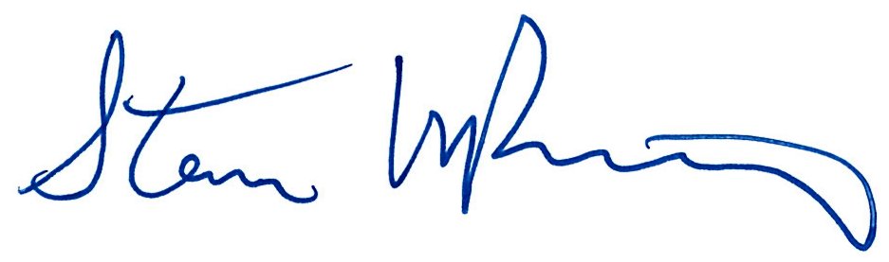
The Earth Science Subcommittee
Steven W. Running, Chair

