Research Campaign – Space Crop Production System to Enable Long Duration Human Exploration Missions Beyond Low Earth Orbit

*Author:* Oscar Monje, 321-298-9272, Amentum, oscar.a.monje@nasa.gov

Introduction:

Generally, space crop production systems are designed to mitigate the risks of inadequate food and nutrition during long duration NASA exploration missions (>3 years). Processed and pre-packaged food loses nutrients during processing and during storage and may not provide the expected nutritional content or have the same taste when consumed. The state-of-the-art (SOA) ISS food system utilizes ambient stored, prepackaged food to deliver ~2-3 kg food crew member-1 day-1. Thus, methods for supplementing the food system with fresh crops supplying bioavailable nutrients (K, Mg; Vitamins B1, C, and K), and antioxidants mitigate the risk of decreased crew performance during long duration exploration missions (Douglas et al., 2021).

Historically, plant growth in space has been studied since the 1960s in multiple small growth plant growth chambers (Zabel et al., 2016). These chambers had little power allocation and were designed for conducting primarily spaceflight biology experiments. New technologies for controlling temperature, humidity, CO2 concentration, and root zone moisture were developed over time (e.g. including the development of LED lighting and optimal substrate based water/nutrient delivery systems) for use in space farming experiments (Monje et al., 2003). However, the biological responses obtained in microgravity were routinely confounded by indirect effects of the spaceflight environment (Stutte et al., 2015). These indirect effects on the biology were caused by the lack of bouyancy-driven convection (causes poor mass and heat transfer to leaves and organs) and capillary-driven moisture redistribution in the absence of gravity, phase separation and lack of sufficient ventilation. The major findings in the 2000-2010 decade were that plant growth, as well as the development of reproductive organs, were similar compared to ground studies when these indirect effects were mitigated by providing sufficient aeration to the root zones, proper ventilation, and adequate CO2 concentration to the shoots of plants during spaceflight (Stutte et al., 2015; Zabel et al., 2016). The chambers utilized low light (100-300 µmol m-2 s-1 PAR) and it was unknown if the plants would develop at similar rates when the light levels were to be increased. In spite of space plants having similar rates of photosynthesis and transpiration compared to 1g plants, there were numerous reports of stress genes being activated as well as cellular changes in response to the spaceflight environment (Monje et al., 2005; Stutte et al., 2005; Stutte et al., 2006).

The 2011 Decadal Survey stated that understanding how terrestrial biology responds to reduced gravity will reduce exploration risks to crews and enable bioregenerative life support. It identified a need to understand sensory mechanisms in cells, plants and microbes; radiation effects on plants/microbes; characterizing responses to the spaceflight environment, as well as exploring the role of plant/microbiome interactions and their role in life support systems. Numerous studies were conducted, but perhaps the biggest impact to the area of space crop production was the development of the Veggie and the Advanced Plant Habitat (APH) Facilities deployed now on the ISS (Morrow et al., 2016). These facilities remove previous engineering-imposed environmental stresses, provide constant environment (light, CO2, temperature, RH, moisture), and APH can compensate for physical changes (diffusion, convection, moisture redistribution) that occur during spaceflight. They have been used to demonstrate the growth of 10 pick-and-eat crops, as well as demonstrate the growth of arabidopsis, wheat, radish, and pepper plant canopies (Douglas et al., 2021; Khodadad et al., 2020, Monje et al., 2020). In spite of these successes, these facilities are operated like spaceflight biology experiments, where used root modules are often discarded after a single growout, which is unsustainable for use during long duration exploration missions limited by resupply constraints. For example, scaling the 0.2 m2 APH SOA rooting system to a salad machine producing 13 crops of Outredgeous lettuce per year (365 d/ 28 d growth cycle) produces 5.3 kg of lettuce, but requires the resupply of 52 kg of media and 0.6 kg of fertilizer.

Future improvements – New Plants and Chamber Subsystems

Several soilless watering technologies are needed to improve the sustainability of the Veggie and APH platforms by avoiding their need for constant resupply of single-use porous media (Monje et al., 2019). Aeroponics has been used to reduce the use of soils for crop production (Zabel et al., 2020), and the Omni-gravity hydroponic system uses recent advances in microgravity fluidics to address challenges for water containment, providing sufficient aeration to roots, and liquid/gas separation issues in microgravity (Mungin et al., 2019). The efficacy of plant growth in a porous tube nutrient delivery system and an on-demand watering systems have been compared to the hydroponic nutrient film technique (Monje et al., 2019). However, the hydroponic systems to grow bigger plants probably because the root morphology of plant roots is different leading to higher nutrient uptake and higher turgor pressure that drives leaf expansion during development.

Newly identified plant species and cultivars with improved growth habits and contents of antioxidants, vitamins, and minerals when grown at super elevated CO2 concentrations found in spacecraft are needed. Veggie cultivar selection trials found that the growth environment affects seed germination, growth habits, biomass production rates as well as plant nutritional value and even flavor. Plants grown at elevated CO2 grow faster and have less transpiration (Monje and Bugbee, 1998; Monje et al., 2019). Furthermore, growth at elevated CO2 also results in decreased nutrients (zinc, iron, and vitamins; Loladze et al., 2014). These findings suggest that the development of genetically engineered plants (e.g. developed using current synthetic biology techniques) may be needed to improve the nutritional content of crop plants growing in spacecraft. For example, plants with improved accumulation of metabolites (Selma et al., 2021), improved tolerance for growth under salt stress (e.g. as observed in plants grown in urine derived fertilizers) (Medford et al., 2017), having modified plant forms (Brophy et al., 2018) that may be more compatible with soilless watering systems, or using plants with altered levels of root suberin (Baxter et al., 2009).

Improved methods for monitoring plant health and ensuring food safety without continuous crew intervention are also desirable (Monje et al., 2019); Monje et al., 2021). Future food production systems may be outfitted with imaging systems for monitoring crop growth and or food safety in near real-time. The candidate sensors to be evaluated include a range of remote sensing tools including visible to far-infrared, hyperspectral, thermal and fluorescence imaging. These systems may respond by raising alarms when stress due to nutrient deficiencies, drought, flooding, or microbial/fungal infections are detected, thus giving time for the crew to mitigate the problems causing stress and thus ensure food safety. Eventually these systems could become autonomous and incorporate artificial intelligence (AI) for automated responses.

Finally, automated sanitization systems are needed to refurbish the crop production systems after a crop is harvested. Currently, the experiments in Veggie and APH end after the crops are harvested. Automated sanitization systems are needed to maintain the crop production system clean during repeated cropping cycles. A system could be implemented on ISS if/when hydrogen peroxide generation becomes available on ISS (Vijapur et al., 2019). Currently, crop production systems are susceptible to growth from biofilms and cleaning requires crew time.

New Science on New Platforms

Currently, space crop production studies occur in the Veggie and APH facilities on ISS. Ohalo III, a new and larger chamber to be used for testing soilless watering systems on ISS will become available in the next decade (Douglas et al., 2021). Thus, the ISS will allow testing of more sustainable crop production systems in microgravity under the radiation regime found in Low Earth Orbit.

As Artemis progresses, the Gateway should include a crop production chamber for studying plant responses to microgravity + deep space radiation. Such a platform is needed to investigate how plants respond to deep space radiation. The Gateway may operate at lower atmospheric pressure, so ground studies should be used to determine if low pressure would affect crop responses (e.g. is germination, vegetative growth, flowering, fruit or root formation, yield and palatability) or if the addition of deep space radiation also altered these crop responses. If deep space radiation altered crop growth, then ground studies would be used to find new cultivars that were less affected or even develop genetically modified plants using synthetic biology approaches that were less affected. The size and autonomy of the Gateway crop production facility is unknown, but its requirements should include sensors (imaging or gas exchange – Monje et al., 2020, Monje et al., 2021) to determine crop growth nondestructively, as Gateway is more remote and sample return of plant samples may not be feasible or possible. Thus, the Gateway platform could be more spartan and a more autonomous set of subsystems may be needed. It should also include methods for seeding and for sanitization so that it could still produce multiple crop growouts sustainably and maintaining a suitable level of food security.

As Artemis continues, subsystem testing should be funded to test tech demos in preparation for partial g growth on the lunar surface. Thus, lunar rovers and an eventual lunar surface habitat will be made available to test the Gateway food production system in a partial g + deep radiation environment on the Moon. Although seeds were germinated on the Moon during China’s recent 2019 Chang’e 4 lunar lander mission (cotton seed), plant growth and development under the (partial g x ionizing radiation) environment on the Moon has not been demonstrated. The impact of ionizing radiation on crop plants remains a critical gap in spaceflight radiation research - short-term acute exposures do not mimic chronic low dosage exposures. Ionizing radiation effects include reduced germination and seed viability, as well as the potential for abnormal growth due to DNA damage. In turn, partial g affects plant growth and moisture distribution phenomena.

**Goal of Research Campaign:** To develop a robust and sustainable space crop production system that enables a manned mission to Mars by supplementing the packaged food system chosen with a palatable, nutritious and safe source of fresh crops.

The approach depicted in the next 2 tables attempts to suggest what, where, and when is to be done during the research campaign to achieve the stated goal. The crops chosen (salad or fruting crops/ microgreens) as well as the technologies developed are to be left open for the engineering / science community to work out. This approach however determines what the campaign must achieve in terms of products - demonstrations of cultivation (multiple growouts) and demonstrations of technologies. The timeline includes the present efforts, the next decade broken out in 3-year cycles, and a post 2030 period. It is envisioned that the resulting space crop production system will only supplement the food system, however as a lunar habitat matures into the next decade then crop testing would begin on caloric food crops. The knowledge gained will benefit crop production on Earth as the data obtained in Monje and Bugbee (1998) was incorporated into a new formulation for vertical farming of wheat in the near-future (Asseng et al., 2020)

Table 1 – Where – What – and When – Demonstrations of Space Crop Production

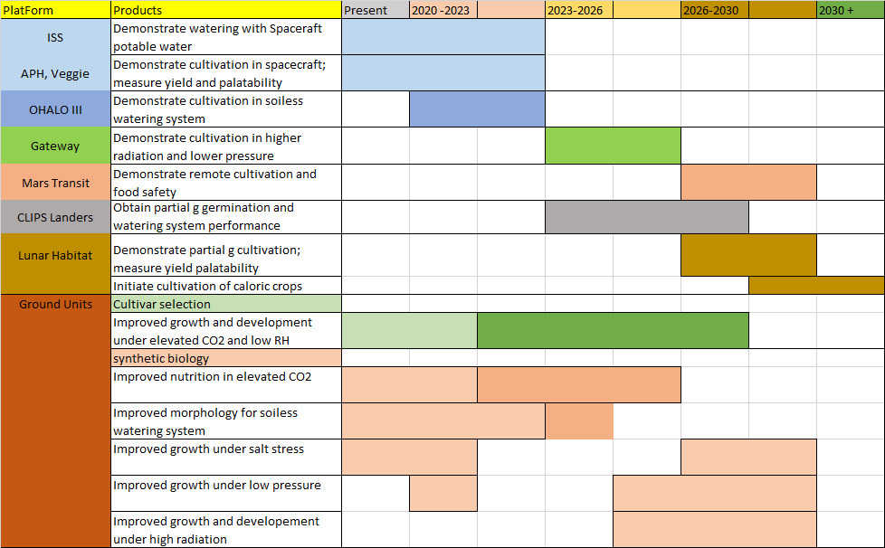

Table 2 – Where – What – and When – Demonstrations of Space Crop Production Technologies

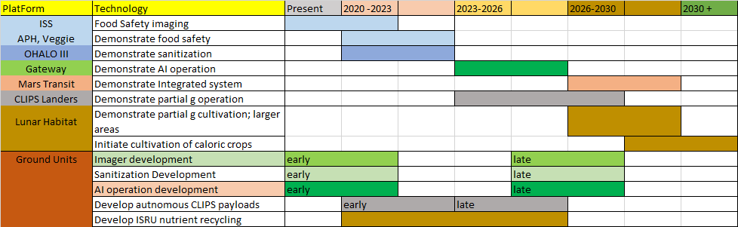

*References*

Asseng, S., Guarin, J.R., Raman, M., Monje, O., Kiss, G., Despommier, D.D., Meggers, F.M., and Gauthier, P.P.G. (2020) Wheat yield potential in controlled-environment vertical farms. Proceedings of the National Academy of Sciences 117, 19131-19135; DOI: 10.1073/pnas.2002655117

Baxter I, Hosmani PS, Rus A, Lahner B, Borevitz JO (2009) Root suberin forms an extracellular barrier that affects water relations and mineral nutrition in Arabidopsis. PLoS Genet 5: 1000492

Brophy JAN, LaRue T, Dinneny JR. (2018) Understanding and engineering plant form. Semin Cell Dev Biol. 79:68-77. doi: 10.1016/j.semcdb.2017.08.051.

Douglas, G. L., Wheeler, R. M., & Fritsche, R. F. (2021). Sustaining Astronauts: Resource Limitations, Technology Needs, and Parallels between Spaceflight Food Systems and those on Earth. Sustainability, 13(16), 9424. <https://doi.org/10.3390/su13169424>.

Escobar, C., Altaf, N., Barker, R., Bhuiyan, M., Correll, M., Fritsche, R., Humphrey, S., Jaiswal, P., Lantin, S., Larkin, E., Price, A., Tabetah, M., Toma, C., "Research Campaign - Artificial Intelligence for Autonomous Space Plant Production", A Research Campaign White Paper for Submission to the Biological and Physical Sciences in Space Decadal Survey 2023 - 2032.

Garland, J.L., L.H. Levine, N.C. Yorio, J.L. Adams, and K.L. Cook. (2000). Graywater processing in recirculating hydroponic systems: Phytotoxicity, surfactant degradation, and bacterial dynamics. Water Research 34:3075-3086.

Khodadad Christina L. M., Hummerick Mary E., Spencer LaShelle E., Dixit Anirudha R., Richards Jeffrey T., Romeyn Matthew W., Smith Trent M., Wheeler Raymond M., Massa Gioia D. (2020) Microbiological and Nutritional Analysis of Lettuce Crops Grown on the International Space Station. Frontiers Plant Sci, 11, 199. DOI=10.3389/fpls.2020.00199.

Loladze I (2014) Hidden shift of the ionome of plants exposed to elevated CO2 depletes minerals at the base of human nutrition. Elife. doi: 10.7554/eLife.02245

Medford, June & Diane, Diane. (2017). Growing beyond: Designing plants to serve human and environmental interests. Current Opinion in Systems Biology. 5. 10.1016/j.coisb.2017.08.008.

Morrow, R.C., Richter, R.C., Tellez, G., Monje, O., Wheeler, R.M., Massa, G.D., Dufour, N., and Onate, B. (2016) A new plant habitat for the ISS. ICES-2016-320.

Monje, O., Nugent, M.R., Spencer, L.E., Finn, J.R., Kim, M.S., Qin, J., Romeyn, M.W., Orourke, A.E., and Fritsche, R.F. (2021) Design of a Plant Health Monitoring System for Enhancing Food Safety of Space Crop Production Systems. ICES-2021-289.

Monje, O., Richards, J.T., Carver, J.A., Dimapilis, D.I., Levine, H.G., Dufour, N.F., and Onate B.G. (2020) Hardware Validation of the Advanced Plant Habitat on ISS: Canopy Photosynthesis in Reduced Gravity. Frontiers in Plant Science 11, 673; DOI: 10.3389/fpls.2020.00673

Monje, O., and Bugbee, B. (2019) Radiometric Method for Determining Canopy Stomatal Conductance in Controlled Environments. Agronomy 9, 114.; DOI: 10.3390/agronomy9030114

Monje, O., Nugent, M.R., Hummerick, M.E., Dreschel, T., Spencer, L.E., Romeyn, M.W., Massa, G.D., Wheeler, R.M., and Fritsche, R.F. (2019) New frontiers in food production beyond LEO. ICES-2019-260.

Monje, O. (2018) The role of plants and algae in near-term life support systems. ICES-2018-252.

Monje, O., S. Anderson, and GW Stutte. (2007). The effects of elevated root zone temperature on the development and carbon partitioning of spring wheat. 2007. J. Amer. Soc. Hort. Sci. 132, 178-184.

Monje O, Stutte G, Chapman D. (2005). Microgravity does not alter plant stand gas exchange of wheat at moderate light levels and saturating CO2 concentration. Planta 222:336-45.

Monje O, GW Stutte, GD Goins, DM Porterfield, and GE Bingham. (2003). Farming in space: Environmental and biophysical concerns. Adv. Space Res. 31:151-167.

Monje O., and B Bugbee. (1998) Adaptation to High CO2 Concentration in an Optimal Environment: Radiation Capture, Canopy Quantum Yield and Carbon Use Efficiency. Plant, Cell and Environ. 21:315-324.

Mungin, R. M., Weislogel, M. M., Hatch, T. R., McQuillen, J. B., "Omni-gravity Hydroponics for Space Exploration," 49th International Conference on Environmental Systems, ICES-2019-24.

National Research Council’s 2011 Decadal Survey Report (2011) Recapturing a Future for Space Exploration: Life and Physical Sciences Research for a New Era.

Selma, S, N Sanmartín, A Espinosa-Ruiz, S Gianoglio, MP Lopez-Gresa, M Vázquez-Vilar, V Flors, A Granell, D Orzaez. (2021) Custom-made design of metabolite composition in N. benthamiana leaves using CRISPR activators. bioRxiv 2021.07.12.452005; doi: <https://doi.org/10.1101/2021.07.12.452005>

Stutte, G.W., Monje, O., Wheeler, R.M. (2015) International Space Station Researcher’s Guide to Plant Science. Ed. A. Rai. NASA ISS Program Science Office.

Stutte, GW, Monje O, Hatfield, RD, Paul, AL, Ferl, RJ, and Simone CG. (2006). Microgravity effects on leaf morphology, cell structure, carbon metabolism and mRNA expression of dwarf wheat. Planta 224:1038-1049.

Stutte, GW, Monje, O, Goins, GD, and Tripathy, BC. (2005). Microgravity effects on thylakoid, single leaf, and whole canopy photosynthesis of dwarf wheat. Planta 223:46-56.

Zabel, P, M. Bamsey, D. Schubert, M. Tajmar (2016) Review and analysis of over 40 years of space plant growth systems. Life Sci. Space Res., 10, pp. 1-16. <https://doi.org/10.1016/j.lssr.2016.06.004>.

Zabel P., Zeidler C., Vrakking V., Dorn M., and Schubert D. (2020) Biomass production of the EDEN ISS space greenhouse in Antarctica during the 2018 experiment phase. Front. Plant Sci. 11:656. doi: 10.3389/fpls.2020.00656

Wheeler, R. (2009). Roadmaps and Strategies for Crop Research for Bioregenerative Life Support Systems. *NASA Technical Memorandum,* 214768.

Wheeler, Raymond M. (2010) Plants for human life support in space: from Myers to Mars. Gravitational and Space Research 23.2.

Wheeler, R.M. (2017). Agriculture for space: People and places paving the way. *Open Agriculture* 2: 14-32.

Vijapur, SH., Hall, T.D., Taylor, E.J., Wang, D., Snyder, S., Skinn, B., Pena Duarte, A., and Cabrera, C.R. (2019) In-Situ Resource Utilization for Electrochemical Generation of Hydrogen Peroxide for Disinfection ICES-2019-38.