Distributed Clock/Sensor Networks in Space for Fundamental Physics
A Topic White Paper submitted to
Decadal Survey on Biological and Physical Sciences Research in Space 2023-2032

Andrei Derevianko¹, Scott Diddams^{2,3}, Leo Hollberg⁴, Matt Hummon², John Kitching^{2,3}, and Frank Quinlan²

¹Department of Physics, University of Nevada, Reno, Nevada, 89557
²Time and Frequency Division, National Institute of Standards and Technology, Boulder, CO 80305
³Department of Physics, University of Colorado, Boulder, CO 80309
⁴Department of Physics, Stanford University, Stanford, CA 94305

Primary Author Contact Information:
John Kitching
National Institute of Standards and Technology
MS 847, 325 S. Broadway, Boulder, CO 80305
Phone: (303)-497-4083, Email: john.kitching@nist.gov
For decades, atomic clocks have carried out some of the most precise tests of fundamental physics, from aspects of the theory of relativity [2] to time variation of fundamental constants [3] and constraints on ultralight dark matter [4]. These tests are enabled by the exquisite precision of the best atomic frequency standards, combined with their quantum-mechanically defined sensitivity to fundamental perturbations such as potential coupling to exotic fields and matter. These experiments are typically carried out by comparing the frequencies of a small number (two or three) of highly precise atomic clocks with different couplings to the phenomenon of interest over an extended time interval. Such experiments necessarily have limited detection bandwidth to time-varying couplings due to the high quality factor of the atomic transitions being interrogated and the need for long averaging times to suppress white noise. And in the case where such clocks are collocated or nearby, the experiments have reduced sensitivity to spatially varying phenomena.
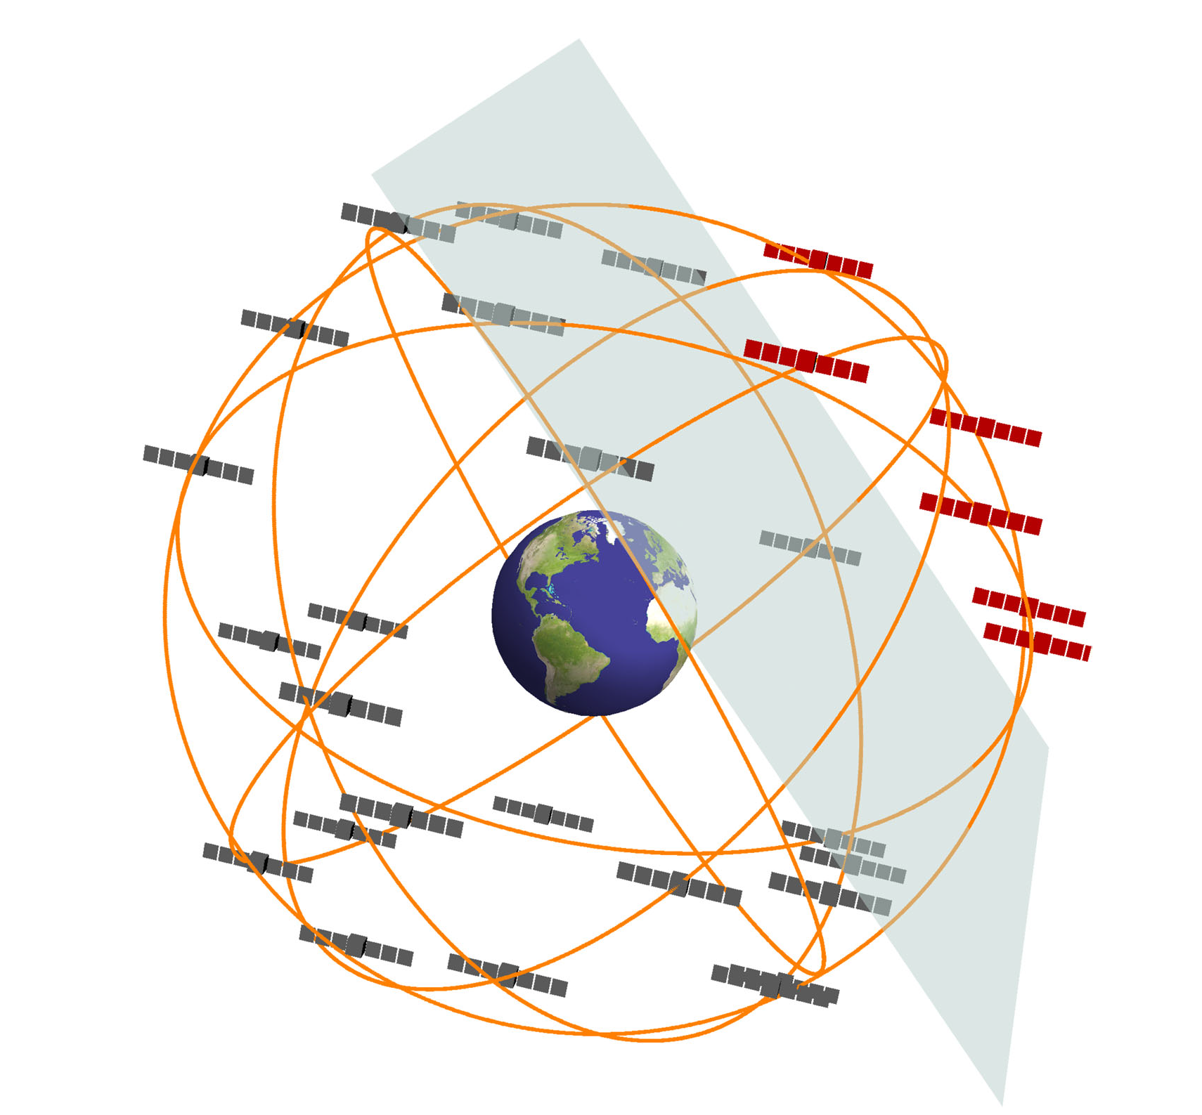
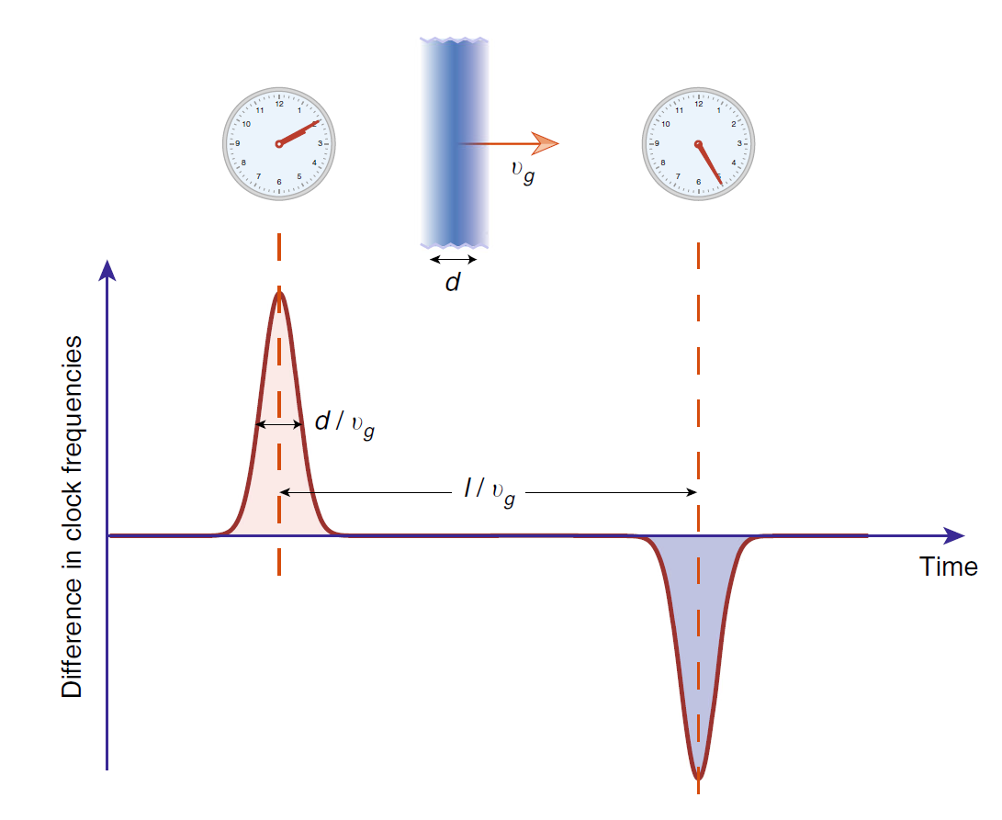
Recently, networks of distributed sensors have been proposed to enable the detection of transient or spatially varying fields. The GNOME project [5, 6] is a network of sensitive, time-synchronized ground-based magnetometers distributed over several continents that is searching for axion-like fields of astrophysical origin. Such fields can have the form of a domain wall that propagates through space and hence interacts with the distributed network in manner correlated with the position of each node. Measurements using atomic clocks on board GPS satellites have been used [1] to search for spatially varying (“clumped”) dark matter that interacts with standard model particles in some way that produces small changes in the clock frequency. And sensor networks combined with clocks have been proposed [7] to search for exotic low-mass field bursts that could be produced in cataclysmic astrophysical events such as black hole mergers and would be correlated with other observables such as gravitational waves or radio-frequency signals. Similarly, a network-based search for non-self-interacting (“wavy”) dark matter was proposed in [8] aimed at correlating oscillating dark-matter signals across network nodes.
Figure 1 (a) Illustration of a domain wall passing through a network of satellite-based atomic clocks. (b) The effect of a domain wall passing through a pair of clocks spatially separated along the propagation axis of the domain wall. From Ref. [1].
(a)
(b)
The main advantages of a distributed clock network in space are that 1) the directionality of the source or velocity of the domain wall sweep can be obtained from the spatially-dependent timing of perturbations to the clocks or sensors; 2) the system is less sensitive to random technical events in individual clocks: if such events are uncorrelated with the exotic-physics-prescribed spatial patterns of individual clock perturbations, they can be ruled out; 3) operation in space rather than on the ground would avoid certain screening of dark matter fields by the atmosphere and the Earth that can substantially reduce sensitivity of terrestrial measurements; and 4) the rapid orbit time in LEO (≈ 90 min) can help distinguish preferred frame effects (e.g. solar, CMB, galactic halo, galactic center) from thermal diurnal 24 hour effects on Earth. Additional advantages related to networks deployed in space are that timing fluctuations due to atmospheric disturbances can be avoided; higher sampling rates can be achieved than are possible with ground-based GPS satellite monitoring; and that multipath effects can be avoided. The network could be deployed on its own as a stand-alone mission, or as a complement to a larger mission such as Fundamental Physics with an Optical Clock Orbiting in Space (FOCOS).
Over the last two decades, considerable progress has been made in the development of compact clocks and sensors for precision measurement. Commercial chip-scale microwave atomic clocks [9, 10] now exist that can achieve fractional frequency stabilities below 10⁻¹¹ at 1000 seconds while consuming only 120 mW of power and compact atomic magnetometers have been developed [11, 12] that can sense magnetic fields below 10 fT. Recently, similar fabrication techniques have been brought to bear on optical atomic frequency references [13] and stabilities as low as [14] 10⁻¹⁴ have been achieved for integration times of ~ 100 seconds using, for example, the two-photon transitions in Rb. Even better stabilities, approaching 10⁻¹⁵, have been demonstrated [15] using spectroscopy of molecular iodine. These optical references are therefore a factor of 10 to 100 better than GPS clocks at integration times from 1 second to 1000 seconds. Simultaneously, lasers locked to compact Fabry-Perot cavities [16] with stabilities near 10⁻¹⁵ below 100 s have been demonstrated in a volume of only a few cubic centimeters. Such instruments would be suitable for deployment on compact, power-limited platforms.
One advantage of vapor cell optical references and compact optical cavities is that high measurement bandwidths can be achieved. These bandwidths are set by atomic transition or cavity linewidths which are typically in the range of 100 kHz. This means that clock measurements can be made on time scales of tens of microseconds, as opposed to several seconds needed for higher-performance instruments. The higher bandwidth can be important for some measurements as described below.
Cubesats, satellites with a volume of several liters and a mass of several kilograms, have emerged over the last decade as an important and inexpensive space vehicle. Over 1600 such satellites have been launched so far and launches of several hundred satellites per year are projected in the coming half decade. Typically, these are deployed into Low-Earth Orbits (LEOs), but recently deployment into Geosynchronous Orbits (GSO) at an altitude above 30,000 km has been achieved. The orbit is important since it sets the length scale for the network and hence the time interval over which an exotic field might be expected to cause perturbations to the network clocks. Clocks deployed in GSO could in principle be separated by five times more than clocks on the ground, while clocks deployed in LEO could have orbital speeds 15 times faster than on the ground. Exotic fields produced by transient astrophysical events would be expected to propagate at roughly the speed of light and would traverse a GSO in about 200 ms. On the other hand, cosmically stationary domain walls through which the earth passes at galactic velocities (~ 300 km/s) would traverse a GSO in about 3 minutes. These time scales indicate that clocks with good stability in the range of 10 ms – 1000 s are ideal.
We propose a series of experiments in which precise but compact optical atomic clocks and/or high-stability lasers locked to high-finesse optical cavities are deployed on ~ 100 cubesat platforms launched into orbit around the earth. Satellites would be equipped with high-quality GPS receivers for precision timing and star trackers and reaction wheels for attitude control and stabilization. The relative frequencies of the atomic clocks and the optical cavities would be compared and time-stamped on board each cubesat and these differences relayed to a ground station via standard data transfer protocols. Such measurements would allow tests of anisotropy of space such as Lorenz symmetry violations since the optical cavity has a preferred direction, while the atom systems have reduced or different directional sensitivities. The platforms themselves would be synchronized with precision microwave or optical timing links between individual platforms and/or a ground station so that relative clock deviations between the nodes of the network could be monitored. Effects such as the passage of a burst of exotic low-mass fields through the network would be observed as changes in the clock time correlated with the position of each network node. The sensitivity to such phenomena would be 2-3 orders of magnitude better than previous tests [1] due to the improved clock Allan deviation at optical frequencies. Optical cavities deployed alone could achieve many of the proposed scientific goals described here themselves, especially those related to perturbations travelling at the speed of light.
Many additional instruments could be included on the cubesat network to broaden the range of physical phenomena being searched for. Compact accelerometers would allow searches for small forces acting on the satellites caused by lumpy dark matter. Such measurements could be complemented by precision position measurements between satellites enabled by the stable lasers via interferometry.
References
[1] B. M. Roberts et al., "Search for domain wall dark matter with atomic clocks on board global positioning system satellites," Nature Communications, vol. 8, Oct 2017, Art. no. 1195.
[2] R. F. C. Vessot et al., "Test of Relativistic Gravitation with a Space-Borne Hydrogen Maser," Physical Review Letters, vol. 45, no. 26, p. 2081, 1980.
[3] J. D. Prestage, R. L. Tjoelker, and L. Maleki, "Atomic Clocks and Variations of the Fine-Structure Constant," (in English), Physical Review Letters, vol. 74, no. 18, pp. 3511-3514, May 1 1995.
[4] K. Beloy et al., "Frequency ratio measurements at 18-digit accuracy using an optical clock network," (in English), Nature, Article vol. 591, no. 7851, pp. 564-+, Mar 2021.
[5] M. Pospelov, S. Pustelny, M. P. Ledbetter, D. F. J. Kimball, W. Gawlik, and D. Budker, "Detecting Domain Walls of Axionlike Models Using Terrestrial Experiments," Physical Review Letters, vol. 110, no. 2, p. 021803, 01/11/ 2013.
[6] S. Afach et al., "Characterization of the global network of optical magnetometers to search for exotic physics (GNOME)," Physics of the Dark Universe, vol. 22, pp. 162-180, 2018/12/01/ 2018.
[7] C. Dailey et al., "Quantum sensor networks as exotic field telescopes for multi-messenger astronomy," Nature Astronomy, vol. 5, no. 2, pp. 150-158, Feb 2021.
[8] A. Derevianko, "Detecting dark-matter waves with a network of precision-measurement tools," Physical Review A, vol. 97, no. 4, Apr 2018, Art. no. 042506.
[9] S. Knappe et al., "A microfabricated atomic clock," (in English), Applied Physics Letters, vol. 85, no. 9, pp. 1460-1462, 2004.
[10] R. Lutwak, "The SA.45S Chip-Scale Atomic Clock - Early Production Statistics," in Precise Time and Time Interval (PTTI) Meeting, Long Beach, CA, 2011, pp. 207-220.
[11] V. Shah, S. Knappe, P. D. D. Schwindt, and J. Kitching, "Subpicotesla atomic magnetometry with a microfabricated vapour cell," Nature Photonics, vol. 1, no. 11, pp. 649-652, 2007.
[12] R. Mhaskar, S. Knappe, and J. Kitching, "A Low-Power, High-Sensitivity Micromachined Optical Magnetometer," Applied Physics Letters, vol. 101, p. 241105, 2012.
[13] Z. L. Newman et al., "Architecture for the photonic integration of an optical atomic clock," Optica, vol. 6, no. 5, pp. 680-685, 2019.
[14] Z. L. Newman et al., "High-performance, compact optical standard," Optics Letters, vol. 46, no. 18, pp. 4702-4705, 2021/09/15 2021.
[15] T. Schuldt et al., "Development of a compact optical absolute frequency reference for space with 10−15 instability," Applied Optics, vol. 56, no. 4, pp. 1101-1106, 2017/02/01 2017.
[16] J. Davila-Rodriguez et al., "Compact, thermal-noise-limited reference cavity for ultra-low-noise microwave generation," Optics Letters, vol. 42, no. 7, pp. 1277-1280, 2017/04/01 2017.

