Topical: “Next generation lunar laser retroreflectors for fundamental physics and lunar science”  
A topical white paper submitted to  
the Committee on the Biological and Physical Sciences Research in Space 2023-2032 of  
The National Academies of Sciences of the USA

L. Porcelli1\*, D. G. Currie2, M. Muccino1,3, S. Dell’Agnello1, D. Wellnitz2, P. Villoresi4,  
G. Vallone4, S. Capozziello5, J. Carpenter6, N. Boersma6, L. Cacciapuoti6, G. Bianco7,  
C. Benedetto7, D. Dequal7, T. W. Murphy8,9, J. Chandler9,10, N. H. Johnson1,  
V. Viswanathan11,12, E. Mazarico11, S. Merkowitz11, L. Angelini11, J. G. Williams13,  
S. G. Turyshev13, A. I. Ermakov14, N. Rambaux15, A. Fienga15,16, C. Courde16, J. Chabé16,  
J.-M. Torre16, A. Bourgoin17, A. Hees17, C. Le Poncin-Lafitte17, G. Francou17,  
S. Bouquillon17, M.-C. Angonin17, U. Schreiber18, L. Biskupek19,  
J. Müller19, T. M. Eubanks20, C. Wu2, S. Kopeikin21

1 National Institute for Nuclear Physics (INFN-LNF), via E. Fermi 54, Frascati (Rome), Italy  
2 Department of Physics, University of Maryland (UMD), College Park, MD 20742, USA  
3 aeroTecno s.r.l., Rome, Italy  
4 University and INFN of Padua, Padua, Italy  
5 University *“Federico II”* and INFN of Naples*, Via Cinthia, I-80126, Naples, Italy*  
6 *ESA-ESTEC, Noordwijk, The Netherlands*  
7 *Italian Space Agency - Space Geodesy Center (ASI-CGS), Matera, Italy*  
8 Physics Department, University of California San Diego (UCSD), San Diego, CA, USA  
9 Center for Astrophysics and Space Sciences (CASS), La Jolla, CA, USA  
10 Harvard-Smithsonian Center for Astrophysics (CfA), Cambridge, MA, USA  
11 NASA Goddard Space Flight Center, 8800 Greenbelt Rd., Greenbelt, MD 20771, USA12 University of Maryland, Baltimore County, 1000 Hilltop Cir., Baltimore, MD 21250, USA  
13 Jet Propulsion Laboratory (JPL), California Institute of Technology, Pasadena, CA 91109, USA  
14 Department of Earth and Planetary Science, University of California, Berkeley, CA 94720, USA  
15 IMCCE, CNRS, Observatoire de Paris, PSL Université, Sorbonne Université, Paris, France  
16 Géoazur, CNRS, Observatoire de Côte d’Azur, Valbonne/Caussols, France  
17 SYRTE, Observatoire de Paris, PSL Research University, CNRS, Sorbonne Universities, UPMC Univ. Paris 06, LNE, France  
18 Institute for Astronomical and Physical Geodesy, Technische Universität München, Germany  
19 Institute of Geodesy, Leibniz University of Hannover, Schneiderberg 50, Hannover, Germany  
20 Space Initiatives Inc., 572 Burlington Ave. NE, Palm Bay, FL 32907, USA  
21 Dept. of Physics and Astronomy, University of Missouri, Columbia, MO 65211, USA

\* Contact information:Dr. Luca Porcelli  
INFN-LNF, Via Enrico Fermi 54  
00044 Frascati (RM), Italy  
Email: luca.porcelli@lnf.infn.it  
Tel: +39 06 9403 2733

Abstract: Lunar Laser Ranging (LLR) data represent a powerful tool to understand the dynamics of the Earth-Moon system and the deep lunar interior. Over the past five decades, the ground station technology has significantly improved, whereas the lunar laser retroreflector arrays (LRAs) on the lunar surface did not. Current instrumental LLR error budget is dominated by the spread of the returning laser pulse due to the large size of the arrays. Next-generation single solid lunar Cube Corner Retroreflectors (CCRs) of large optical diameter (whose LLR performance is unaffected by that time spread) aim to fully exploit the current laser ranging station capabilities to attain LLR accuracy below current centimeter value down to the desired millimeter level and much higher data collection rates. Such improvements will have a significant impact, enabling more refinedephemerides, improved tests of General Relativity (GR) and of other theories of relativistic gravity in the Sun-Earth-Moon system and improved knowledge of the properties of the lunar interior.

I. Introduction

This white paper presents the scientific objectives of single, large, next generation CCRs of uncoated fused silica developed over the past 15 years for lunar missions in the 2020s. These instruments share a common optics design [1], inherited from Apollo LRAs, and currently consist of American and European payload implementations approved for NASA Commercial Lunar Payload Services (CLPS) missions in late 2023 and early 2024, respectively. We recommend that the collective functionalities to be demonstrated by these two payload implementations[[1]](#footnote-1), their lander accommodations and landing sites serve as a shared (at least) US-EU baseline for LLR science during the CLPS, Artemis and European Large Logistics Lander (EL3) lunar programs. Single, large next-generation CCRs (Figure 1) will significantly expand the Apollo legacy and open the path to improved tests of GR, like weak and strong equivalence principle, geodetic precession, inverse-square force-law and more stringent constraints on possible time changes of the gravitational constant G.

[An external file that holds a picture, illustration, etc.
Object name is 41114_2016_7_Fig7.jpg](https://www.ncbi.nlm.nih.gov/pmc/articles/PMC5253913/figure/Fig7/) 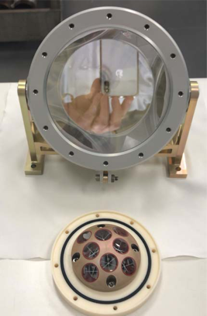 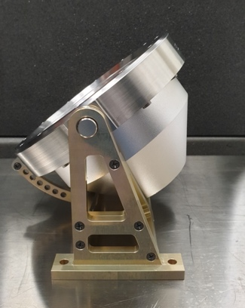

Figure 1 – NGLR 10-cm solid reflector next to an Apollo 38-mm CCR (left; credits: D. G. Currie) and next to a Martian microreflector like the ones onboard Perseverance and ExoMars (middle; credits: ASI-INFN). Side view of a MoonLIGHT in a fixed-pointing mount with pre-launch selectable elevation (right; credits: ASI-INFN).

In the 1970s LLR measurements had a precision of a meter, then reached about 20 cm. Apollo and Lunokhod 1/2 LRAs contributed a negligible fraction of the instrumental LLR error budget. Nowadays, after the upgrade of the ground station ranging capabilities by more than two orders of magnitude, old generation LRAs dominate the LLR error budget due to lunar librations, while LLR to single, large CCRs is unaffected by those librations (Figure 2), like the librations in longitude (about 8° during the 28 days lunar phase) produced by the eccentricity of the Moon orbit **[1]**. Because of this effect, that is proportional to the LRA dimension (see Figure 2 and Figure 3), one corner of old generation lunar LRAs can be several centimeters farther from the Earth with respect to the opposite one. The effect on range accuracy is estimated to be (15‒50) mm**[2]**. By averaging over a large number N of lunar returns, ground stations reduce the range accuracy by a factor down to 1 cm **[3]** (based on data before operation of APOLLO[[2]](#footnote-2)) and up to few mm**[4]** (APOLLO data). However, this is achieved at the expense of averaging thousands of precious laser returns to build a so-called LLR *normal point*, while next-gen CCRs, being single reflectors, support mm-level accuracy with nominally every single laser return. In the long term they will fully support laser pulses of 10‒20 ps of width and further improvements in the ground stations capabilities (including even shorter laser pulses), which may lead to a CCR contribution to the LLR error budget below the millimeter.

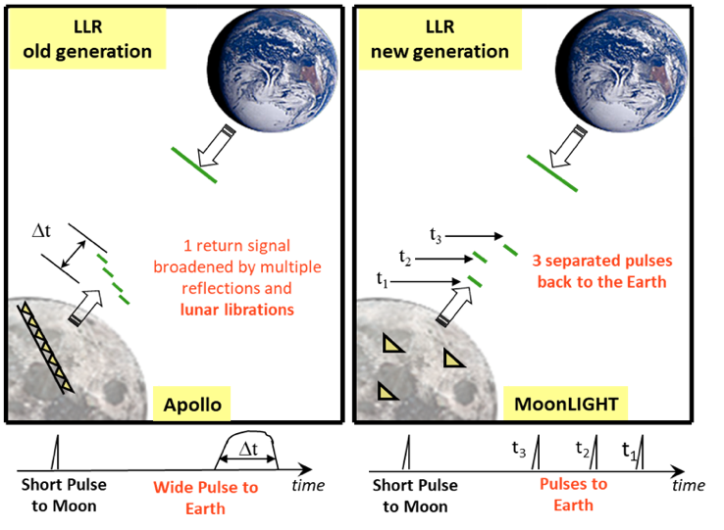

*Figure 2* – *Comparison between the broadening of the laser return pulse from old generation LRAs due to the libration tilt (left) vs separated laser return pulses from next-gen CCRs unaffected by lunar librations (right).*

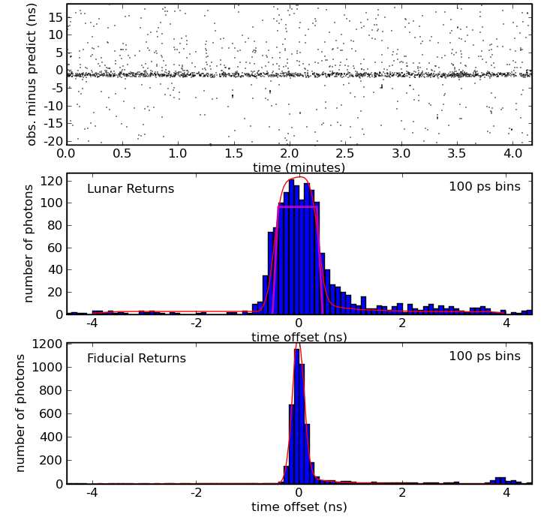

Figure 3 – An Apollo 15 run. Top: an observed 40 ns window (range subtracted) round trip time. Middle: a histogram of the return photons with its fit (red line) obtained by convolving the fiducial CCR return (bottom panel) with a profile modeling the spread from the tilted LRA (magenta). Bottom: the fiducial CCR return of the APOLLO system response (credits: <https://tmurphy.physics.ucsd.edu/apollo/highlights.html>).

In the first four decades the efficiency of old generation LRA has degraded by a factor of 10, likely because of slow lunar dust deposition over their surfaces **[5]**. At least for their first decade on the Moon NGLR will not suffer significantly by this effect. In addition, MoonLIGHT will employ a robotic, removable dust cover to protect the CCR face from potential dust accumulation during CLPS landing (see Figure 4).

Apollo LRAs were aligned by astronauts with the center of the Earth taking into account the lunar libration pattern. With the MoonLIGHT Pointing Actuator (MPAc) funded by ESA **[6]**, this alignment will be performed robotically by two actuators (see Figure 4). The deployment of next-gen reflectors (with active Earth-pointing and dust protection at landing) for fundamental physics and geophysics is a goal of ESA’s Strategy for Science on the Moon **[7]**.

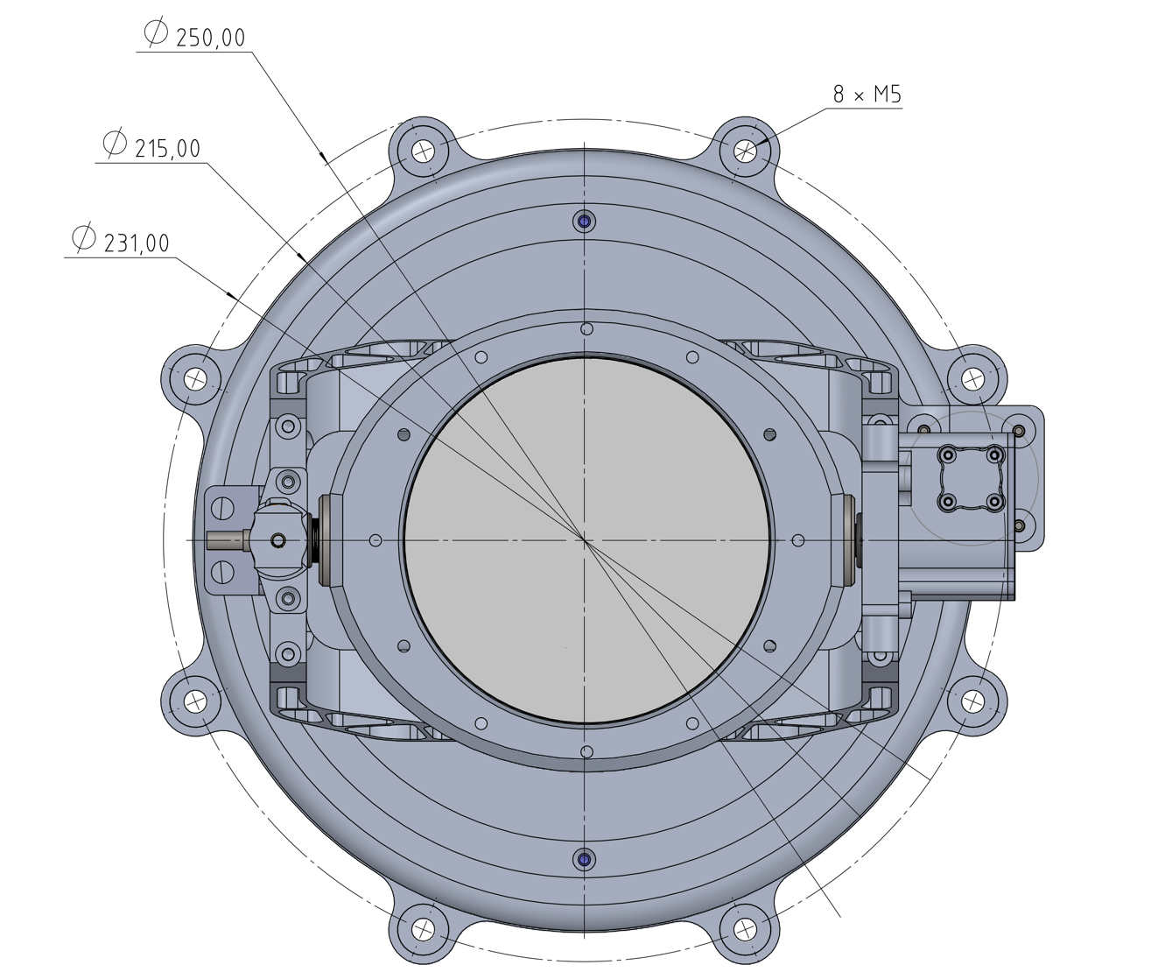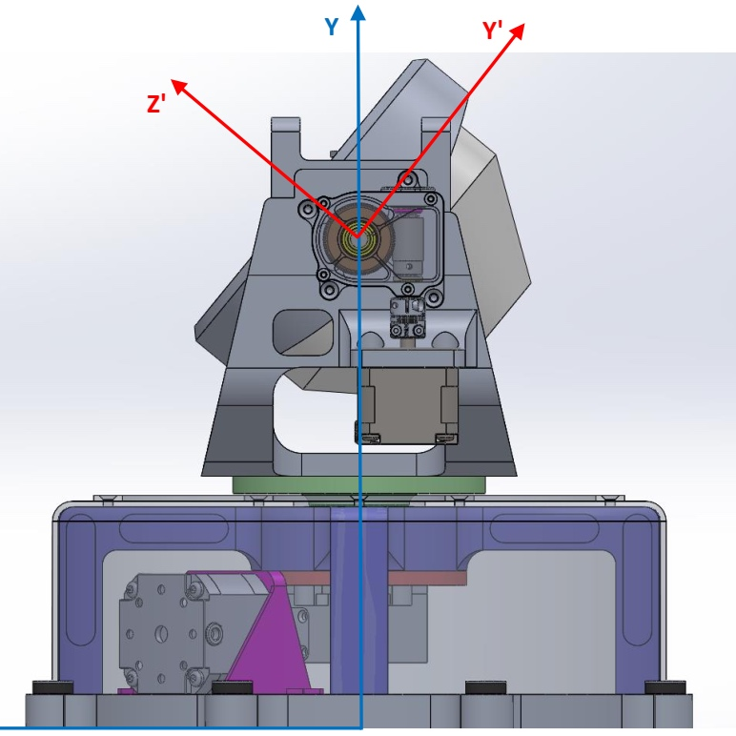 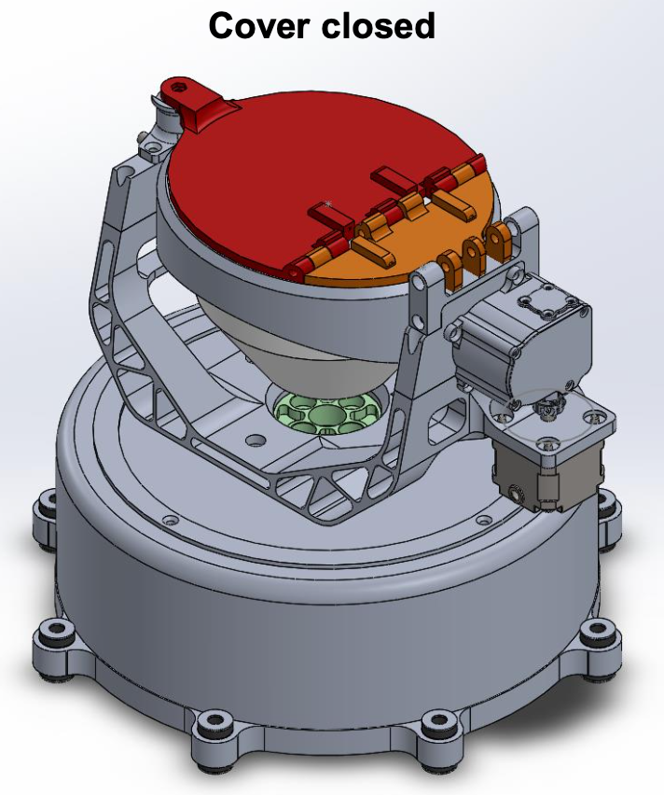 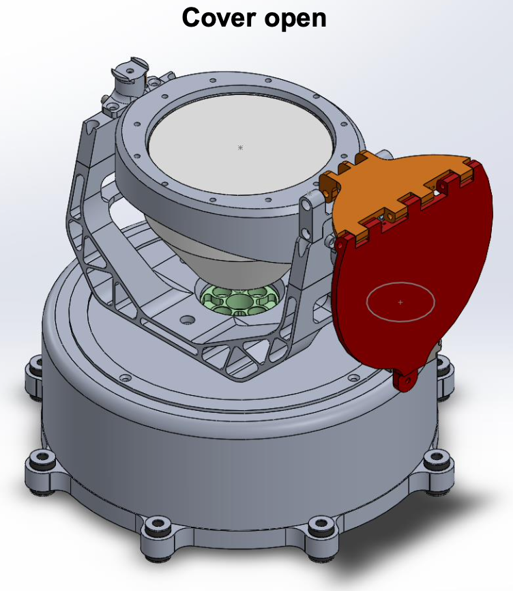

*Figure 4 – Left two figures: top and side views of next-gen CCR integrated into MPAc. Right two figures: next-gen CCR + MPAc with the robotic removable dust cover shown closed and open. Credits: ESA.*

II. Primary Scientific Objectives

Several lunar ephemeris and orbit determination software packages have been developed over the decades by expert analysts who are among the co-authors of this white paper. Historically, one of the very first such packages was the Planetary Ephemeris Program (PEP) by CfA, which estimates the orbits of solar system bodies and of many artificial satellites/probes. One of the first GR measurement with LLR data was the lunar geodetic precession in 1988 **[8]**. Other original software packages have been developed and are actively used at JPL and in Europe (France and Germany). UCSD and INFN-LNF use PEP. All these packages are state-of-the-art and in different ways they constantly keep improving GR tests and pushing constraints on fundamental physics observables in search for new physics, one US decadal plan and one ESA roadmap **[9]** after the other. As a reference example of this collective, international work, Table 1 shows a recent compilation of LLR-based measurements of the Weak Equivalence Principle (WEP), the Strong Equivalence Principle (SEP), the Parametrized Post-Newtonian (PPN) parameter β, the Nordtvedt parameter η, the time variation , the inverse square law (strength α of the Yukawa potential at the Earth-Moon range ) and the geodetic precession KGP. While Table 1 may not be comprehensive of all ongoing efforts and of every single physics measurement under study, it is representative of the quantitative improvements that can be reached by deploying next generation reflectors with CLPS, Artemis and EL3 missions, as well as with a future Lunar Geophysical Network (LGN, see next section).

Finally, LLR is also a powerful tool to test gravity theories beyond GR, like spacetime torsion, through its potential manifestations in two-body systems like: Earth-Moon and Sun-Mercury **[10]** and Earth-LAGEOS/LARES[[3]](#footnote-3) artificial satellites **[11]**. The physics observables of Table 1 can also be used to probe extended theories of gravity beyond GR, like the so-called *f(R) gravity* **[12]** and *Nonminimally Coupled* gravity (NMC) **[13]**. These gravity theories are well motivated by cosmological models **[14]** alternative to dark matter and dark energy, whose apparent effects are explained by modifications of GR, and that may have observable manifestations in the solar system dynamics (and always in the weak-field, slow-motion regime).

Recently, to support the need for accurate and sufficient LLR observations, investigations were carried out in order to assess the benefit of many high-precision infrared (IR) data **[26]**.

Table 1 – Compilation of GR tests with LLR from S. Turyshev et al., NASA BPS Division’s “Lunar Surface Science Workshop Fundamental and Applied Lunar Surface Research in Physical Sciences”, August 2021, and from **[26]**.

|  |  |  |  |
| --- | --- | --- | --- |
| **Fundamental physics measurement** | **Current LLR accuracy of ~1 cm, supported by Apollo/Lunokhod LRAs** | **LLR accuracy of ~1mm, supported by next generation CCRs** | **Ultimate LLR accuracy ~0.1 mm, supported by next generation CCRs** |
| Weak EP | | *a / a* | < 2.4 × 10-14 | < 10-14 | 10-15 |
| Strong EP | | * *| < 3.4 × 10-4 | 3 × 10-5 | 3 × 10-6 |
| PPN β | | *β - 1* | < 7.2 × 10-5 | < 10-5 | 10-6 |
| Time variation of G | | | < 9.5 × 10-15 yr-1 | 5 × 10-15 | < 1 × 10-15 |
| Inverse Square Law | |*α*| < 3 × 10-12 | 10-12 | 10-13 |
| Geodetic precession | |*KGP* - 1| < 6.4 × 10-3 | < 6 × 10-4 | < 6 × 10-5 |

**III. Secondary Scientific Objectives**

Extending the reach of Apollo **[15]** and Lunokhod **[16]** LRAs, next generation CCRs will greatly contribute to lunar surface geodesy (selenodesy) **[17]** by improving the local lunar cartesian reference system and its tie to the International Celestial and Terrestrial Reference Systems (ICRS/ITRS) **[18,19]**. Currently LLR determines the coordinates of Apollo and Lunokhod LRAs w.r.t. the center of mass of the Moon with decimeter level uncertainties. Up to date, these five sites have the most accurately known positions on the Moon and may serve as control points for lunar reference systems **[20,21,22]**, including the one based on Lunar Reconnaissance Orbiter (LRO) data and metric maps, the future LGN, as well as positioning and navigation from orbiters equipped with laser time-of-flight capabilities.

LLR is one of the core technologies of the LGN mission **[23]** (to be proposed by C. Neal, R. Weber et al. for NASA’s New Frontiers 5), where it contributes to the improvement of the determination of the lunar interior structure together with the other LGN instruments.

Concerning lunar inner structure, next-gen single large CCR will contribute in improving the uncertainties of the core momentum and Love numbers of the Moon. Lunar core and inner structure have been probed by several techniques. The lunar mean density and moment of inertia values permit a small dense, solid or liquid core, but not a large one. Seismic data provides information on the elastic properties of the lunar crust and mantle: S-waves damp out for the deep mantle, possibly due to a deep partial melt; P-waves penetrate the deepest mantle better, but are not able to unambiguously detect a core. Magnetic induction data indicates a small conducting core. LLR is sensitive to the physical librations, i.e. the 3-axis lunar rotation and orientation **[24]**. The rotation of the Moon is sensitive to moments of inertia of lunar mantle and fluid core, lunar gravity field, tidal deformation, dissipation at the CMB (Core-Mantle Boundary) and flattening at the CMB. LLR physical libration analysis indicates a liquid lunar core, first detected from dissipation at the CMB and more recently from detection of CMB flattening and core moments of inertia; according to the core moments values and CMB flattening, the fluid core radius is determined to be ~380 km **[25]**. Next-gen CCRs will further significantly contribute to the determination done by GRAIL (the Gravity Recovery And Interior Laboratory mission) and existing LLR data of tidal Love numbers which are sensitive to internal elastic properties and structure including a core: in particular the displacement Love number h2, which is compatible with the foregoing core size though the k2 Love number would work better with a smaller core. A future wider selenographical distribution of next generations CCRs would help to single out the contribution of physical librations from LLR data and would lead to the increase in sensitivity not only of physical librations, but also of tides. Correspondingly, this would improve the uncertainties of the core moments and Love numbers.

**IV. First Approved Missions and Decadal Recommendations**

The first NGLR (with fixed pointing) will be launched with a NASA-CLPS mission dubbed Ghost Blue and the lander provider will be Firefly. The launch is scheduled for Q4 2023 and the landing site will be the Mare Crisium. The first MoonLIGHT (equipped with MPAc and the robotic dust cover) will be launched the NASA-CLPS/PRISM1A (CP-11) mission and the lander provider will be assigned in the November 2021 timeframe. The launch is scheduled for Q1 2024 and the landing site will be the Reiner Gamma swirl region.

This topical white paper wishes to recommend to the BPS decadal survey the state-of-the-art objectives of fundamental physics and lunar science described in sections II and III, that are enabled by next generation single, large diameter CCRs deployed by means of NASA-CLPS missions, through the international Artemis Accords, the EL3 lunar program and the LGN during the decade 2023-2032. The science return will continue for the following decades because CCR are passive, long-lived instruments and as demonstrated during the past 50+ years by Apollo and Lunokhod LRAs (one of which was rediscovered in 2010 by APOLLO thanks to LROC, the LRO Camera). Since all existing LRAs are north of the lunar equator, we recommend one or more southern landing or roving sites, especially towards the limbs or the south pole, as they would be most helpful both for lunar science and for fundamental physics.

Concerning rover opportunities, if (for example) NASA’s Volatiles Investigating Polar Exploration Rover (VIPER) does not include one, it could deploy a next-gen CCR of increased performance, like the one in Figure 1 in a fixed-pointing mount with pre-launch selectable elevation (middle and right photos). At its end-of-life VIPER could maneuver to align the CCR to Earth, avoiding the need for MPAc (i.e. an active pointing). Such a next-gen CCR would be a cost-effective, science-effective (because deployed at the south pole), compact and light instrument (<2kg, dust cover included). ESA’s robotic, removable CCR cover (Figure 4 or a version simplified/optimized for VIPER’s 85oS latitude) would be most useful to avoid regolith dust accumulation over the 10-cm diameter CCR face during the rover traverses.

**Acknowledgements**

Work by INFN-LNF authors is supported by ESA under Contract n. 4000129000/19/NL/TFD (and a NASA-ESA MoU for CP-11) and by ASI under Agreement n. 2019-15-HH.0. D. G. Currie acknowledges the support of NASA under Contract n. 80MSFC20C0012 (LSITP).

**References  
[1]** Currie, D.G., et al. (2013), *Nuclear Physics B (Proc. Suppl.)*, 243-244, 218, <https://doi.org/10.1016/j.nuclphysbps.2013.09.007>, and Martini, M., et al., *Planetary and Space Science*, 74, 276-282 (2012), <https://doi.org/10.1016/j.pss.2012.09.006>.

**[2]** Murphy, T.W., Jr. et al., *Classical and Quantum Gravity*, 29, 184005 (2012), <https://doi.org/10.1088/0264-9381/29/18/184005>.

**[3]** Williams, J., Turyshev, S., Boggs, D., Ratcliff, J., *Advances in Space Research*, 37, 67-71 (2006), <https://doi.org/10.1016/j.asr.2005.05.013>.

**[4]** Battat, B.R., et al., *PASP*, 121, 29 (2009), <https://doi.org/10.1086/596748>.

**[5]** Murphy, T.W., et al., *Icarus* 208, 31-35 (2010), <https://doi.org/10.1016/j.icarus.2010.02.015>.

**[6]** ESA Contract No. 4000129000/19/NL/TFD.

**[7]** ESA UNCLASSIFIED - Releasable to the Public, “ESA Strategy for Science at the Moon”.

**[8]** Shapiro, I., Reasenberg, R.D., Chandler, J.F., and Babcock, R.W., *Phys. Rev. Lett*., 61, 2643-2646 (1988), <https://doi.org/10.1103/PhysRevLett.61.2643>.

**[9]** *ESA Roadmap for Fundamental Physics in Space* (2021), <https://ideas.esa.int/apps/IMT/UploadedFiles/00/f_4fb71b16fa6ad1e0d4bdfb8a2f25cde9/01_PhysicalSciences_Fundamental_Physics.pdf?v=1634194116>.

**[10]** March, R., et al., *Phys. Rev. D*, 83, 104008 (2011), <https://doi.org/10.1103/PhysRevD.83.104008>.

**[11]** March, R., et al., *Gen. Relativ. Grav.*, 43, 3099-3126 (2011), <https://doi.org/10.1007/s10714-011-1226-2>.

**[12]** Capozziello, S., D’Agostino, R., Luongo, O., *Int. J. of Mod. Phys. D*, 28, 10, 1930016 (2019), <https://doi.org/10.1142/S0218271819300167>.

**[13]** March, R., Páramos, J., Bertolami, O., Dell’Agnello, S., *Phys. Rev. D*, 95, 024017 (2017), <https://doi.org/10.1103/PhysRevD.95.024017>.

**[14]** Damour, T., Piazza, F., Veneziano, G., *Phys. Rev. D*, 66, 046007 (2002), <https://doi.org/10.1103/PhysRevD.66.046007>.

[**15]** Bender, P.L., et al., *Science*, 182, 229-238 (1973), <https://doi.org/10.1126/science.182.4109.229>.

**[16]** Fournet, M., *Le réflecteur laser de Lunokhod*., in: Bowhill, S.A., Jaffe, L.D., Rycroft, M.J. (Eds.), Space Research Conference, Vol. 1 of Space Research Conference, pp. 261-277 (1972).

**[17]** Viswanathan, V., et al. (2021). Extending Science from Lunar Laser Ranging. *Bulletin of the AAS*, 53(4). <https://doi.org/10.3847/25c2cfeb.3dc2e5e4>.

**[18]** [Charlot, P.,](https://ui.adsabs.harvard.edu/#search/q=author:%22Charlot%2C+P.%22&sort=date%20desc,%20bibcode%20desc) et al., *A&A*, 644, 159, 28 (2020), <https://doi.org/10.1051/0004-6361/202038368>.

**[19]** Altamimi, Z., Rebischung, P., Métivier, L., Collilieux, X., *J. Geophys. Res.,* 121, 6109-6131 (2016), <https://doi.org/10.1002/2016JB013098>.

**[20]** Davies, M.E., Colvin, T.R., Meyer, D.L., Nelson, S., *J. Geophys. Res*., 99, 23211-23214 (1994).

**[21]** Wagner, R.V., et al. (2017), *Icarus*, 283, 92, <https://doi.org/10.1016/j.icarus.2016.05.011>.

**[22]** Kopeikin, S., <https://ui.adsabs.harvard.edu/abs/2010AcPSl..60..393X/abstract>.

**[23]** Haviland, H., et al. (2021), arXiv:2107.06451.

**[24]** Williams, J.G., Boggs, D.H., Ratcliff, J.T., *39th* *Lunar and Planetary Science Conference*, League City, Texas, p.1484 (2008).

**[25]** Viswanathan, V., Rambaux, N., Fienga, A., Laskar, J., & Gastineau, M. (2019), *Geophysical Research Letters*, 46(13), 7295-7303, <https://doi.org/10.1029/2019GL082677>.

**[26]** Biskupek, L., Müller, J., and Torre, J.-M. (2021): Benefit of New High-Precision LLR Data for the Determination of Relativistic Parameters, *Universe*, 7, 34, <https://doi.org/10.3390/universe7020034>.

1. Next Generation Laser Retroreflector (**NGLR**) by UMD, funded by NASA, and Moon Laser Instrumentation for General relativity/geophysics High-accuracy Tests (**MoonLIGHT**) by INFN, funded by ESA and ASI. [↑](#footnote-ref-1)
2. Apache Point Observatory Lunar Laser-ranging Operation, New Mexico, USA. Other LLR stations are in EU, in Grasse (France), Matera (Italy), joined recently by stations in Wettzell (Germany), and Yunnan (China). [↑](#footnote-ref-2)
3. LAser GEOdynamics Satellites / LAser RElativity Satellites. [↑](#footnote-ref-3)