# Topical: “Disabled People: A Quarter of the Population, Yet Often Overlooked In Diversity, Equity, and Inclusion Discussions and Efforts”

**Primary Author:** Dr. Ashley Macner

**Institution:** Unaffiliated

**Co-author:** Dr. Christina Johnson

**Institution:** Kennedy Space Center

**Endorsers:**

Lindsay Jones

Dr. Gioia D. Massa

Matthew Romeyn

## Introduction

When we talk about diversity, equity, and inclusion (DEI), the focus is often on race and women. While we have made some progress in these areas, we still have a lot of work to do. More recently, the scope of DEI has expanded to include LGBTQIA+ and has adopted more inclusive language regarding gender identity and expression. However, one area that needs attention and that is rarely mentioned in DEI, is disabled peoplea. Disabled people face significant systemic barriers to higher education and employment in the biological and physical sciences. Intersections amongst combinations of these marginalized groups present additional challenges. We cannot increase DEI, when people from these historically marginalized groups are missing from the table. At present, they are missing from positions of power and influence. While this white paper focuses entirely on the barriers faced by disabled people, these issues also affect people beyond this specific demographic and the solutions presented will benefit the entire workforce. This white paper will identify the barriers experienced by disabled people and propose solutions to create equitable opportunities and to promote retention in the biological and physical sciences.

## Background

The Americans with Disabilities Act (ADA) has defined disability as the following: “...a physical or mental impairment that substantially limits one or more major life activities, a person who has a history or record of such an impairment, or a person who is perceived by others as having such an impairment [1].” Approximately 27% (see Appendix A for more information) of working age adults (i.e., 18-65) are disabled [2,3], yet they only comprise about 6-10% [4] of the science and engineering (S&E) workforce (cf. Figure 1). From Figure 1, we can see that while generally for all degrees and bachelor’s of science (BS) degrees, the employment percentage generally increases with time for all science and engineering career areas. This trend is not as strong for master’s (MS) degrees, and is almost stagnant for doctoral (PhD) degrees. Because BS and MS degrees make up the majority of awarded degrees, the stagnation trend for PhDs gets washed out when only looking at data for all degrees. Additionally, the difference between BS and PhD for all career areas grows sharply with time (cf. Figure 2). In other words, the more advanced the degree, the smaller the percentage of the STEM workforce is comprised of disabled people. It is unclear why this is worsening with time, and where the roadblocks are for disabled people obtaining and working with an advanced degree.

Examination of the ratio of unemployed disabled people to unemployed non-disabled people who are looking for a job, shows that disabled people are generally 1.5-5 times more likely to be looking for work (cf. Figure 3; left). The people most likely to be looking for work are in the 30-49 age bracket. Furthermore, the ratio of unemployed disabled people to unemployed non-disabled people who are **not** looking for a job, shows that disabled people are more likely to not be looking for a job, especially as they age and then retire out of the workforce (i.e., the 40-75 age bracket). It is important to understand why more disabled people are looking for jobs than non-disabled people, and also why disabled people stop looking for jobs at higher rates. By understanding the drivers, solutions can be proposed.

a In general, identity-first language (i.e., “disabled people”) is preferred as opposed to person-first language (i.e., “person with disabilities”).

|  |  |
| --- | --- |
| A bar chart showing the percent employed with a disability for BS degree holders by specialty and year. The vertical axis is labeled percent employed with a disability and ranges from 0 to 16 percent. The horizontal axis is labeled with the years 2011 through 2019 in increments of 2 years. For each year there are five different colored bars each representing a different specialty: biological/life science, engineering, physical science, science and engineering, and science. In general, the percent employed increases over time for most specialties, raising from between 6 to 8 percent to between 8 to 16 percent. | A bar chart showing the percent employed with a disability for MS degree holders by specialty and year. The vertical axis is labeled percent employed with a disability and ranges from 0 to 16 percent. The horizontal axis is labeled with the years 2011 through 2019 in increments of 2 years. For each year there are five different colored bars each representing a different specialty: biological/life science, engineering, physical science, science and engineering, and science. In general, the percent employed increases over time for most specialties, although to a much lesser degree than those with BS degrees. It increases from between 4 to 6 percent to between 6 to 12 percent at its maximum in 2017. Additionally, there is a slight and noticeable downward trend from 2017 to 2019 by a few percentage points. |
| A bar chart showing the percent employed with a disability for PhD degree holders by specialty and year. The vertical axis is labeled percent employed with a disability and ranges from 0 to 16 percent. The horizontal axis is labeled with the years 2011 through 2019 in increments of 2 years. For each year there are five different colored bars each representing a different specialty: biological/life science, engineering, physical science, science and engineering, and science. In general, the percent employed is largely stagnant between 6 to 8 percent over time for most specialties. There is a spike in 2017 to between 10 to 12 percent for the physical sciences. | A bar chart showing the percent employed with a disability for all (i.e., BS, MS, and PhD) degree holders by specialty and year. The vertical axis is labeled percent employed with a disability and ranges from 0 to 16 percent. The horizontal axis is labeled with the years 2011 through 2019 in increments of 2 years. For each year there are five different colored bars each representing a different specialty: biological/life science, engineering, physical science, science and engineering, and science. In general, the trend increases with time because a large proportion of the degree holders are BS degrees. The increase is from between 6 to 8 percent to 8 to 12 percent. |

**Figure 1.** *Compiled NSF data [4] looking at the employment rate for biological and life sciences (tan), all engineering (orange), physical sciences (red), all science and engineering (blue), and all science (gray) for bachelor’s of science (upper left), master’s (upper right), doctoral degrees (lower left), and all degrees (lower right). Lines indicate the general trend. Please see Appendix B for accompanying data tables.*

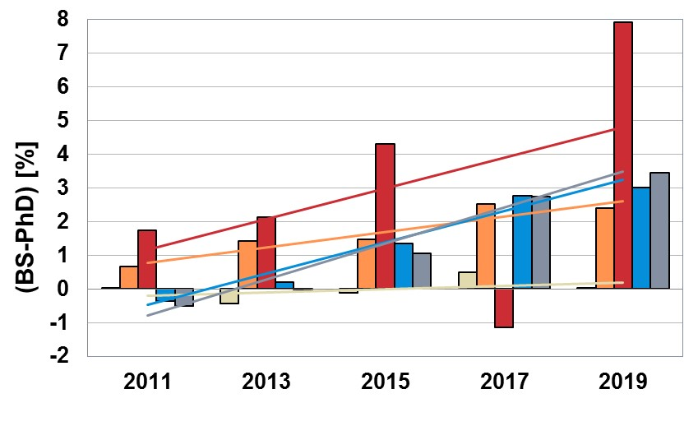

**Figure 2.** *Compiled NSF data [4] looking at the difference between employment rates of disabled people with a BS or a PhD as a function of year and career area: biological and life sciences (tan), all engineering (orange), physical sciences (red), all science and engineering (blue), and all science (gray). Lines indicate the general trend. Please see Appendix B for accompanying data tables.*

|  |  |
| --- | --- |
| A bar chart showing the ratio of unemployed disabled to non-disabled people looking for a job by year and age bracket. The vertical axis is labeled ratio of unemployed disabled to non-disabled seeking employment and ranges from 0 to 6 percent. The horizontal axis contains the age brackets of 29 and younger, 30-39, 40-49, and 50-75 in increasing order. For each age bracket there are five different colored bars each representing a different year: 2010, 2013, 2015, 2017, and 2019. A horizontal parity line is also drawn on the chart, so one can rapidly visualize if there is parity between disabled and non-disabled people. The chart shows that disabled people are generally 1.5-5 times more likely to be looking for work and that the people most likely to be looking for work are in the 30-49 age bracket. | A bar chart showing the ratio of unemployed disabled to non-disabled people not looking for a job by year and age bracket. The vertical axis is labeled ratio of unemployed disabled to non-disabled not seeking employment and ranges from 0 to 6 percent. The horizontal axis contains the age brackets of 29 and younger, 30-39, 40-49, and 50-75 in increasing order. For each age bracket there are five different colored bars each representing a different year: 2010, 2013, 2015, 2017, and 2019. A horizontal parity line is also drawn on the chart, so one can rapidly visualize if there is parity between disabled and non-disabled people. The chart shows that disabled people are more likely to not be looking for a job, especially as they age and then retire out of the workforce (i.e., the 40-75 age bracket). |

**Figure 3.** *Compiled NSF data [4] looking at the ratio of unemployed disabled to non-disabled people seeking employment (left) and not seeking employment (right) as a function of age bracket and time. The horizontal black line is the parity line. Please see Appendix B for accompanying data tables.*

## Barriers & Proposed Solutions

There are many barriers to employment in a STEM career including: burdensome reasonable accommodations (RA) processes, lack of virtual options (e.g., work, business meetings, conferences, etc.), being penalized for resume “gaps,” restrictive job ads, and lack of 50%- and 75%-time job roles. Each barrier will be discussed in detail in its own subsection and a solution will be proposed. Please see Appendix C for a proposed timeline for solution implementation.

### Barrier 1. Accommodations process is overly burdensome to the employee

For qualified disabilities under the ADA, job applicants and employees are allowed to ask for RA to be able to participate in the hiring process and to fulfill the essential job functions, respectively. Accommodations allow disabled people equitable participation in the workforce. While the ADA is a federal law that was enacted 30 years ago, it is still viewed unfavorably by many employers. Under the ADA, while the employer does not need to accept the employee’s exact request, they are required to work with them and come to a solution that works for both parties. Oftentimes what happens is that employers make the process as difficult as possible, dragging out the process several months to the detriment of the employee, to the point where the employee quits. Although the ADA is a federal law, it lacks a lot of teeth enforcement wise. Employers need to be held accountable for ADA compliance by working with disabled people on meeting RA without burdening the employee.

**Barrier 1 Proposed Solutions:**

* Encourage Congress to pass legislation to create a body that enforces the ADA. Failing to comply with the ADA needs to be financially disincentivized.
* Encourage Congress to pass legislation that creates time limits on the accommodations mediation process.
* Implement legislation that requires companies to keep publicly available data on their RA process such as: how long it takes on average, the percent denied, how many people leave the company due to a burdensome process, how many employees sue, etc.

### Barrier 2. Employer resistance to telecommuting and to remote conferences, business meetings

The COVID-19 pandemic showed the business world what was possible. Workforces, conferences, and business meetings went online, and business continued. In general, most employers saw an increase in productivity and employees were happier [5]. Many surveys have consistently shown that most people prefer to work remote for some or all days of the week [6]. It is worth noting that virtual attendance to work, conferences, and business meetings is a RA that is often rejected by employers and universities. With the recent 1+ year experiments, the grounds of rejection are no longer rational. Virtual attendance allows disabled people and other people who are unable to attend in person, the ability to participate professionally. These virtual options must be retained in a post-COVID-19 world.

**Barrier 2 Proposed Solution:** The intention is to move these out of the accommodations process and make them accessible to everyone, no questions asked. Retain remote options for conferences, job roles, and business meetings, and allow employees to choose what works best for them (e.g., 100% in-person, 100% remote, or some combination thereof) **without** penalty (e.g., reduced pay, mandating they live close to a physical office for 100% remote, etc.).

### Barrier 3. Lack of EEOC protection for the unemployed creates a discrimination loophole

People have valid gaps on their resumes. They might have needed to care for an ill family member, left to have and/or raise children, tend to a chronic illness or injury, just needed a break, etc. Disabled people are doubly hurt by this hiring practice, because they sometimes have “gaps” on their resume to manage their illness, which causes them to mention their disability early in the hiring process. While under current EEOC laws employers are technically legally able to discriminate against people who are unemployed, disabled people often face high levels of unemployment and hence are indirectly discriminated against, despite being a protected class themselves. Designating the unemployed as a protected class closes this loophole.

**Barrier 3 Proposed Solution:** Ask Congress to pass federal legislation to designate the unemployed as an EEOC protected class to close a loophole which allows for indirect discrimination against disabled people.

### Barrier 4. Time frame restrictions in job ads

A lot of the early career roles are restricted to people who graduated within the past 5 years. This excludes people who became disabled and left the workforce early in their career. Upon trying to re-enter the workforce, they are excluded from early career roles because their degrees are “too old,” while simultaneously not being experienced enough to apply for an experienced hire role. This makes it almost impossible to re-enter the workforce.

**Barrier 4 Proposed Solution:** Eliminate degree time-frame restrictions in job ads and replace with language pertaining to cumulative experience. Example: Replace “graduated within the past 5 years” with “graduated and has less than 5 years of cumulative experience.” The updated language is less exclusionary and allows for gaps.

### Barrier 5. Lack of 50%- and 75%-time roles with full benefits

There are many reasons why people might want to work less than full-time (e.g., 40 hours). People who have just re-entered the workforce, those managing chronic illnesses, disabled people, parents, caretakers, someone who is retired, etc. STEM jobs are almost always full-time and salaried. Because they are salaried, most jobs end up being 40+ hours a week. 50%- and 75%-time roles should be available to open up opportunities to others to contribute to science, and to be able to make a living. Confining roles to full-time only is exclusionary. These roles should be advertised directly while still being available as a reasonable accommodation, if necessary.

There are some cases where a disabled person might be transitioning from being on disability to working. This is where advertising 50% and 75% jobs becomes important, and here is why. If the ad is written for full-time employment and the employee is “promised” a 50% or 75% role as an accommodation and the employer fails to follow through, this puts the disabled person in a precarious position. The disabled person might not be able to work full-time, and having accepted the job, they have now lost their benefits. Once they are gone, they are impossible or overly burdensome to reinstate.

**Barrier 5 Proposed Solution:** In addition to full-time roles, advertise 50% (20 hour) and 75% (30 hour) roles with full benefits to create more options that can help diversify the workforce. Full benefits should include comprehensive long-term disability policies that don’t discriminate on the basis of pre-existing conditions and that provide benefit parity for mental and physical disabilities.

## Conclusion

There are many barriers to employment in STEM careers for disabled people, all of which can be changed. The widespread teleworking that was common the past 18 months showed us that the accommodations that are denied for disabled people, are in fact, reasonable. An informal poll was conducted on social media regarding how long the RA process generally takes, and over half of respondents said it took at least 3+ months for the process. This is far too long, and forces people out of their jobs. Disabled people, like all people, deserve an equitable opportunity at participating in the workforce. The barriers identified above, if corrected, would go a long way to increasing employment and retention of disabled people in the STEM workforce while improving the working environment for everyone.

## References

[1]<https://www.ada.gov/ada_intro.htm>

[2] <https://www.cdc.gov/ncbddd/disabilityandhealth/infographic-disability-impacts-all.html>

[3] <https://www.census.gov/library/publications/2018/demo/p70-152.html>

[4] <https://www.nsf.gov/statistics/women/>

[5] <https://www.shrm.org/hr-today/news/hr-news/pages/study-productivity-shift-remote-work-covid-coronavirus.aspx>

[6] <https://www.pwc.com/us/en/library/covid-19/us-remote-work-survey.html>

[7] <https://www.cdc.gov/ncbddd/disabilityandhealth/datasets.html>

[8] <https://www.purdue.edu/innovativelearning/accessibility/default.aspx>

[9] <https://stemedhub.org/resources/2637/video?resid=2638&time=00:01:01>

[10] <https://www.w3.org/TR/WCAG20/>

[11] <https://poet.diagramcenter.org/>

[12] <https://medium.com/cafe-pixo/inclusive-color-palettes-for-the-web-bbfe8cf2410e>

## Appendix A

It is important to understand where the percentage of people who are disabled (i.e., ~27%) comes from, as different surveys are used to calculate the numbers. An in-depth discussion of the various survey collection methods can be found on the CDC website [7]. When performing my analyses, I found that there are generally two different numbers in circulation: ~12-15% or ~27%. The ~12-15% numbers generally come from the American Community Survey (ACS), which only contains six questions to assess disability status [7]. The ~27% numbers (reported by the CDC [2] and the United States Census Bureau [3]) are based off of the Behavioral Risk Factor Surveillance System (BRFSS) and the Survey of Income and Program Participation (SIPP) plus the Social Security Administration (SSA) Supplement. Both questionnaires are more comprehensive surveying systems, and both questionnaires do include the six questions from the ACS. Because both surveys are restricted to the civilian noninstitutionalized population of the US, the ~27% is likely an underestimate. In contrast, the 13% estimate provided by the NSF in table 1-3 [4] is based on the data from the ACS.  
  
**So, which number is correct?** In order to answer this question, it is important to understand how the ACS differs from the other two surveys. Not only is the ACS limited in its surveying capacity, but it also only samples subnational geographies. In contrast, the other two surveys are national surveys.

**Why is working with the right number important?** Working with the right number is very important in assessing how successful recruitment and retention efforts are for STEM careers. In looking back at Figure 1, at the chart for all degrees, one might falsely conclude based on the 13% estimate that we are doing a good job. But when compared with what is likely to be a more accurate measure of the percentage of disabled people, we actually are not doing a good job. And as was hopefully shown in this white paper, doing a deeper analysis reveals some more specific issues. The NSF is encouraged to update their tables in accordance with the estimates provided by the CDC and the United States Census Bureau.

## Appendix B: Figure data tables

Providing data tables alongside graphs is a best practice for accessibility of data (see Appendix D for more resources). A table is provided for each figure appearing in this white paper.

**Figure 1**

The values in all of the tables for Figure 1 are the % employed with a disability for the stated specialty.

BS Degree

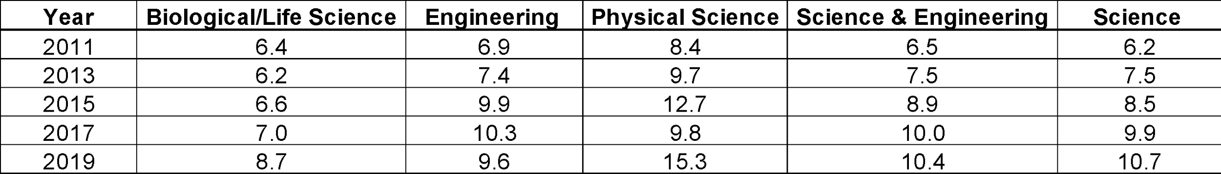

MS Degree

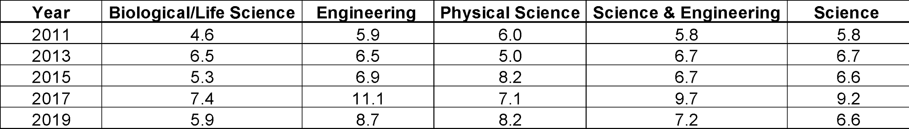

PhD Degree

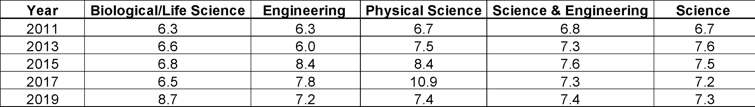

All Degrees

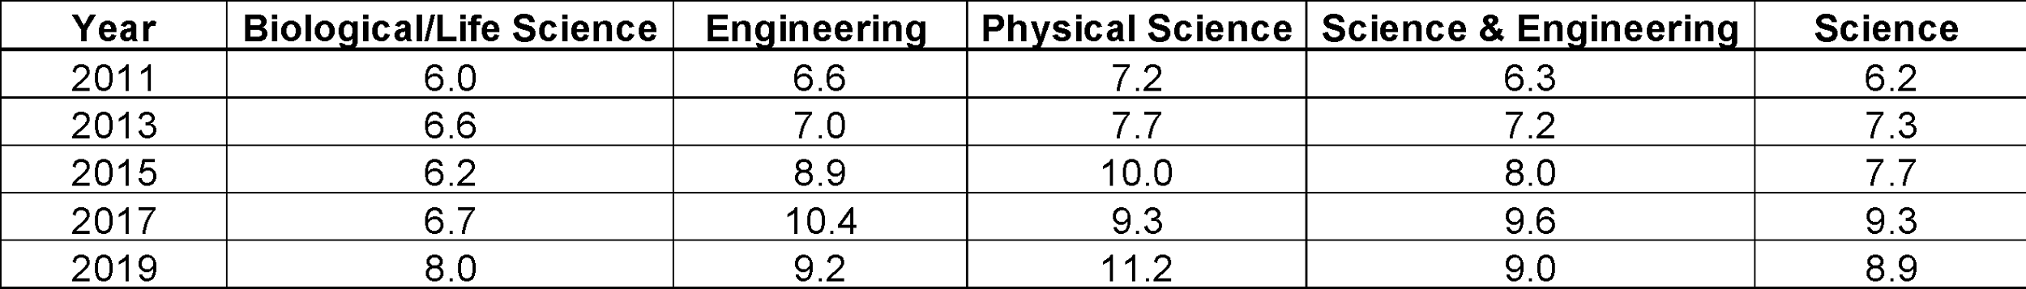

**Figure 2**

The values in the table for Figure 2 are the difference in the percent employed with a disability between BS and PhD degrees (BS-PhD) for the stated specialty.

Corresponding data table for Figure 2. The table contains the differences in the percent employed with a disability between BS and PhD degrees (BS-PhD) for the stated specialty and year.


BS degree holders that shows the percent employed with a disability by specialty and year.

**Figure 3**

Ratio of Unemployed Disabled to Non-Disabled Seeking Employment

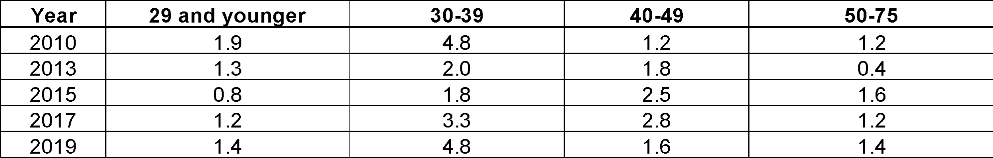

Ratio of Unemployed Disabled to Non-Disabled NOT Seeking Employment

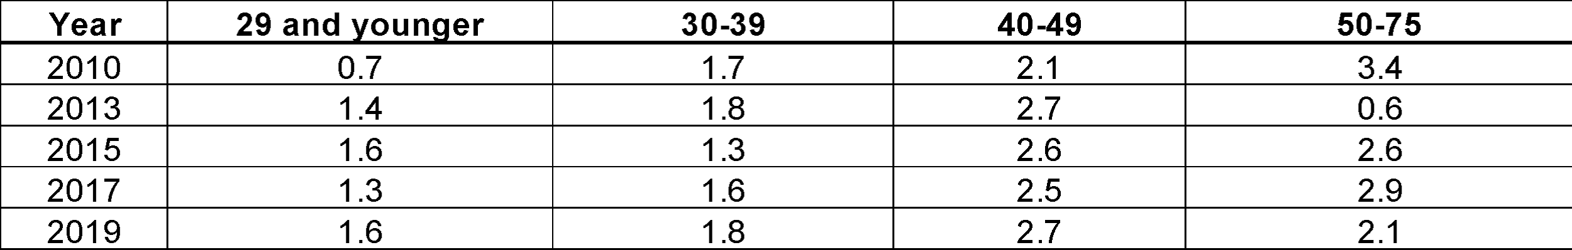

## Appendix C: Gantt chart timeline

A Gantt chart of the expected timeline for solving each barrier is provided. It is worth pointing out that all of the barriers can be solved immediately without waiting for Congress to act. Also, this timeline is highly speculative and is dependent upon the priorities of Congress.

## A Gantt chart that proposes a timeline for achieving the proposed solutions for each barrier. Each row corresponds to one of the barriers. Lessening the burden of asking for reasonable accommodations under the ADA is estimated to take 2 years to legislate. Changing company policies to allow for telecommuting and remote attendance at conferences and business meetings is estimated to take 3 months to implement. Asking Congress to designate the unemployed as an EEOC protected class is estimated to take almost 2 years to legislate. Eliminating degree time frame restrictions in job ads is estimated to take half a year. And coming up with 50%- and 75%-time roles with full benefits is estimated to take half a year.

## Appendix D: Resources for Accessibility Best Practices

Purdue University has a section of their website dedicated to accessibility that gives a great overview of each accessibility area along with specific actions that can be taken [8]. Areas covered include online learning, web content, word documents, other technical documents, video, audio, and course content. The reader is encouraged to check out the website to learn more.   
  
An area not discussed on the website but will be discussed here, is universal laboratory design. Purdue put out a video that gives a virtual tour of the Accessible Biomedical Immersion Laboratory (ABIL), a laboratory that was designed with accessibility in mind [9]. There are many changes that need to be made, in order to make existing laboratories more accessible. Some of these changes include relocation and redesign of emergency showers, swapping out stationary laboratory benches with adjustable height benches, reorganizing the laboratory furniture to maximize efficiency, motion activated equipment, wheelchair accessible sinks and fume hoods, etc.

The Web Content Accessibility Guidelines 2.0, also known as WCAG 2.0, are a very detailed set of recommendations for making web content accessible [10]. These guidelines can also provide a general framework for making printed (non web-based) scientific information accessible.

A comprehensive guide on how to write accurate image descriptions for different types of scientific figures can be found in [11].

When implementing accessibility best practices, it is best to hire people who are formally trained in those practices because there are a lot of nuances and it is a full-time job to properly create accessible laboratories, work environments, media, and products.

## Appendix E: Document accessibility statement

A good faith effort was put forth to make this document as accessible as possible by following current accessibility best practices. This includes the use of a color palette [12] and labels to make the graphs accessible to those with visual impairments. Data tables are also provided for each figure [11]. For those accessing this document with screen readers, H tags are used to denote the document structure and alt text is provided for each figure and data table.