***A Topical White Paper Submitted on 31 October 2021 to the***

**Decadal Survey on Biological and Physical Sciences (BPS) Research in Space 2023-2032**

**A Dedicated, Long Duration Balloon Mission from Antarctica to Study the Effects of Low Dose Galactic Cosmic Radiation on Biology**

**Principal Author:** David J. Smith, 650-279-0227, NASA Ames Research Center, [david.j.smith-3@nasa.gov](mailto:david.j.smith-3@nasa.gov)

**Co-Authors:** Thomas Berger (DLR), Amy Canfield (NASA WFF), Egle Cekanaviciute (NASA Ames), Jack Miller (LBNL), L. Seth Schisler (NASA Ames), Marianne B. Sowa (NASA Ames), Ye Zhang (NASA KSC), Brad Gersey (Space Environment Technologies), Eric Benton (Oklahoma State University)

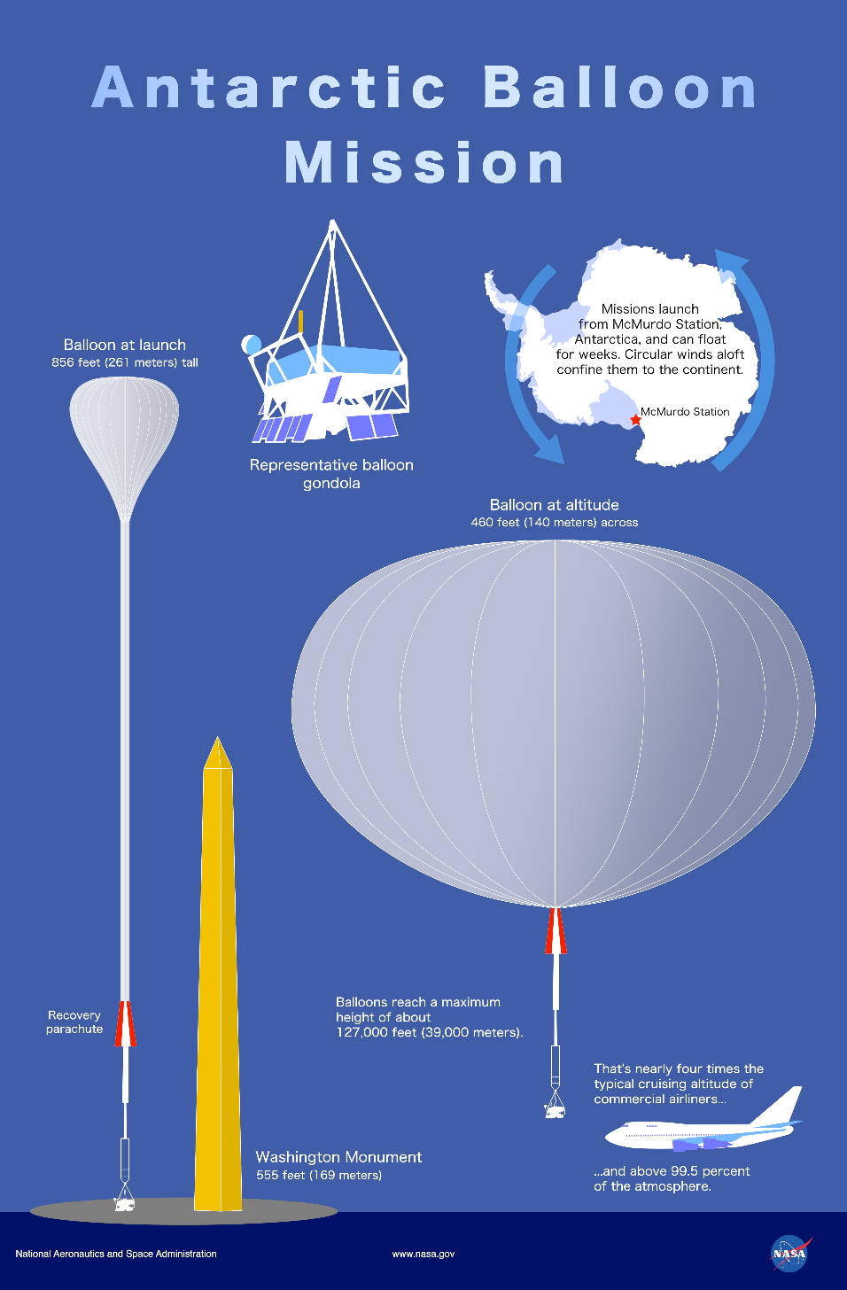

*Cover image reproduced with permission from NASA Goddard Space Flight Center*

1. **Summary**

Antarctic long duration balloon missions flown by NASA’s Science Mission Directorate (SMD) can be used as a surrogate for the deep space radiation environment, reducing the need to launch beyond low Earth orbit experiments to assess the impact of galactic cosmic radiation (GCR) on biology. To date, over fifty NASA balloon missions flown from Antarctica have carried scientific payloads from Astrophysics (APD) and Heliophysics (HPD) in SMD. Only two life science experiments have been flown from Antarctica, and both were ride-along (piggyback) opportunities, limiting the sophistication and types of model organisms incorporated into the studies. Herein, we argue for ***establishing a large, dedicated Antarctic balloon mission for the Biological and Physical Sciences (BPS) Division in SMD to be launched in 2029/2030***, ***with an “omnibus” gondola carrying dozens of Space Biology payloads that would receive a sustained exposure to low dose rate GCR for 30+ days***. Our unprecedented, protracted radiation experiment cannot be done using ground-based simulation facilities or in space; it can only be achieved through an Antarctic balloon mission dedicated to Space Biology payloads. By providing more access to radiation research platforms through existing NASA SMD Antarctic balloon flight opportunities, the Space Biology community would be better positioned to address unknowns associated with low dose rate GCR exposures in long duration spaceflight.

1. **Current Limitations on GCR Research**

Traditionally, researchers seeking space radiation exposures for conducting life science investigations must launch experiments into deep space or simulate the conditions using ground-based facilities. Deep space flight opportunities are infrequent, expensive, and constrained by volume, mass & power. Similarly, ground-based accelerator facilities like the NASA Space Radiation Laboratory (NSRL) at Brookhaven have high costs (~$6k/hr), constraints on minimum dose and dose rate, and limitations with the overall ability to simulate realistic mixed space radiation fields [1]. It is also not feasible to run a continuous, long duration (30+ days) low dose experiment at NSRL.

1. **The Scientific Case: Antarctic Balloon Flights Provide Deep Space GCR Exposures**

Most cosmic radiation particles are deflected around the Earth by its magnetic field. But solar and deep space particles can penetrate through the magnetic north and south poles at latitudes above 70°. Thus, energetic particle radiation from space continuously bombards the Earth’s upper atmosphere, particularly where polar balloon missions float. Antarctic-launched missions can remain aloft in this “near space” radiation-elevated environment for weeks or months, with circular stratospheric winds confining the balloon to the continent, while it carries up to 6,000 lbs of scientific payload, all of which can be continuously powered through solar arrays charged by a Sun that never sets below the horizon in the Antarctic summertime [1].

Key Message:

**GCR expected at human spaceflight destinations (Moon, Mars) can be obtained through existing NASA long duration Antarctic balloon missions; this is a major paradigm shift for how (and where) Space Biology experiments fly to study deep space radiation effects.**

With Si-based dosimeters, our team recently measured ionizing radiation dose rates in the Antarctic stratosphere on a 32-day NASA balloon mission (**Figure 1**) [2], showing the high altitude, high latitude environment as comparable to deep space; not only in dose (**Figure 2**), but also in particle composition. Separately, our team also demonstrated a new payload that can maintain active biological specimens in a pressurized hardware system [3], opening the door for “other than microbial” experiments on balloons. Taken together, these milestones make a clear and compelling case for additional Antarctic balloon flight opportunities in the BPS Division.

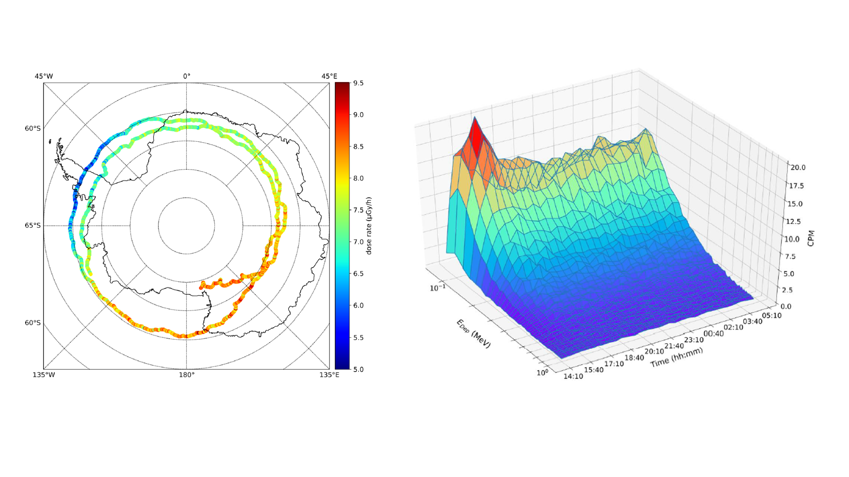

**Figure 1.** (*left*) The measured dose rate profile (μGy/h) for the E-MIST biological piggyback payload flown on a 32-day Antarctic mission in 2018-2019 [2]; (*right*) Energy deposition spectra for first 15 hours of E-MIST Antarctic flight for energy depositions *EDep* ≤ 1MeV in Si [2].

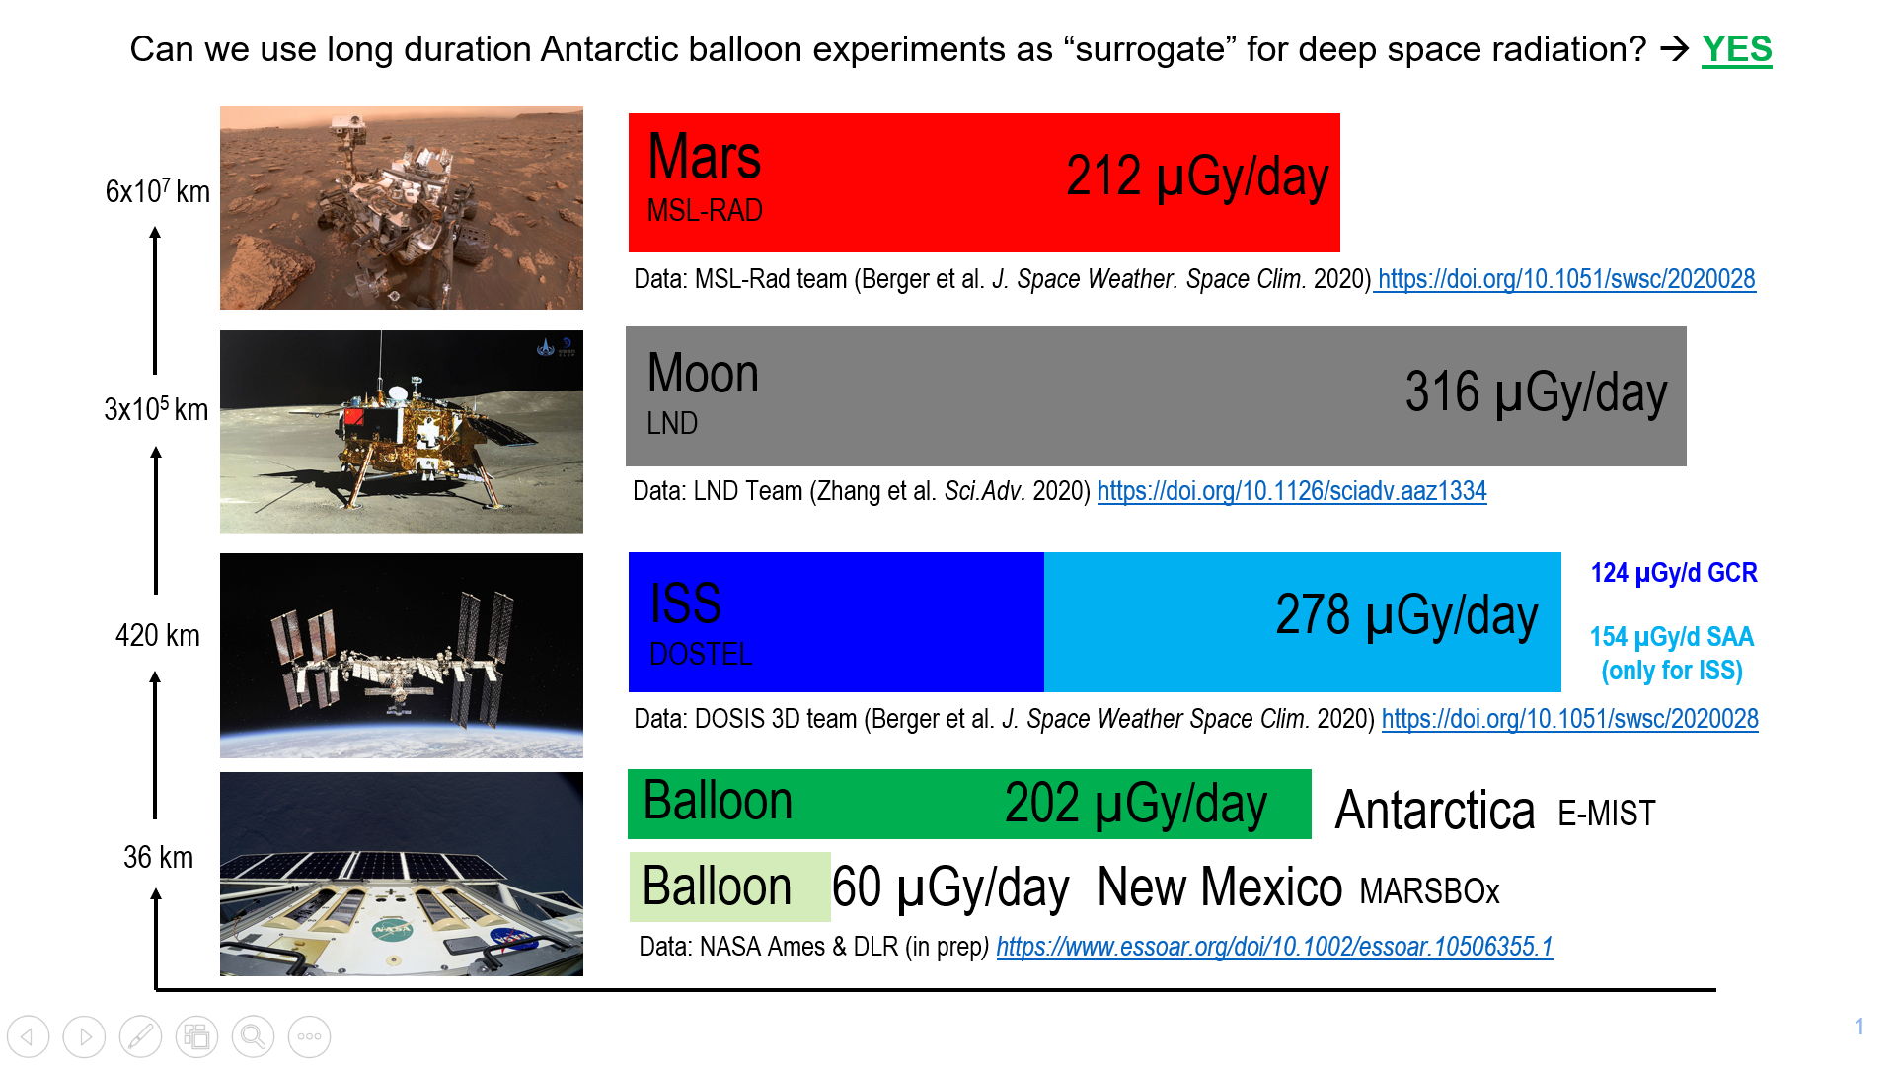

**Figure 2.** Long duration NASAAntarctic balloon missions can provide deep space radiation conditions comparable to human spaceflight destinations (Moon and Mars), based on doses (*dark green* *bar*) reported our team [2].

1. **Why is a Dedicated** **Antarctic Mission Needed?**

The National Science Foundation (NSF) Office of Polar Programs manages the U.S. Antarctic Program and works alongside NASA’s Balloon Program which provides logistic support for all scientific operations, including launch and recovery operations at Williams Field, near McMurdo Station. On average, NASA (with NSF oversight) will support 2 large (dedicated), long-duration launches per year. Thus, dedicated flight opportunities are highly coveted. The decision authority for which 1-2 NASA payloads(s) will received a dedicated flight opportunity is held by NASA SMD. Historically, payloads from APD and HPD have been awarded dedicated Antarctic flights. But NASA's Balloon Program is responsible for supporting all SMD-funded science. **Thus, with the BPS Division now in SMD (as of 2020), the Space Biology community has an unprecedented opportunity for a dedicated Antarctic balloon mission, if authorized and prioritized by SMD**. It is an internal NASA decision and can be realistically implemented.

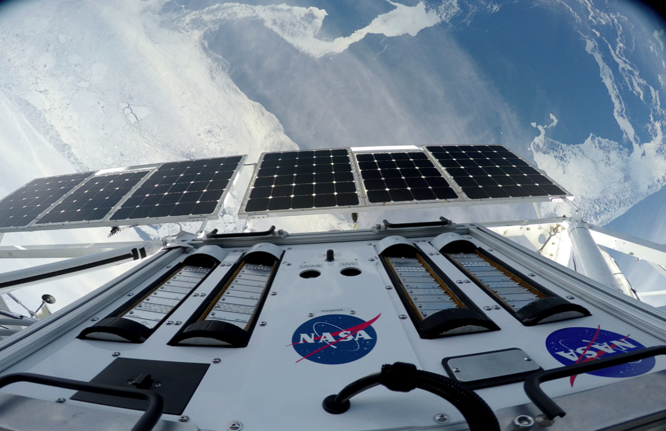

**Figure 3.** The E-MIST payload ascending to the Antarctic stratosphere, flown as a piggyback payload on long duration NASA balloons from 2017-2019 (*ice shelf in view below*).

As piggybacks, two small biological payloads have flown from Antarctica [2, 4], including investigations led by our team (**Figure 3**). ***Why is a larger, dedicated Antarctic mission needed?***

1. Piggybacks must be simple and non-interfering with the primary (dedicated) payload.
2. Piggyback payload teams cannot send scientists to Antarctica (because McMurdo Station resources are severely limited, including bed space for scientific personnel).

Both aforementioned factors are “non-negotiable” for piggyback payloads, constraining the types of biological experiments that can fly. Consequently, a biological experiment from Antarctica (as a piggyback payload) requires specimens to be handed over ~6 months prior to launch for shipping. The timetable for returning a payload from Antarctica can also last ~6 months or more. Most Space Biology model organisms are not stable with prolonged stasis. **Thus, a dedicated Antarctic flight opportunity would allow for higher fidelity, more sophisticated biological experiments, with on-ice research teams supporting late load and post-flight processing activities at McMurdo Station**. Instead of only flying plant seeds or microbes, Space Biology teams could instead plan experiments with othermodel organisms, including active specimens.

1. **Plausible Path Forward**

The key pieces are already in place for supporting a large dedicated Antarctic balloon mission for Space Biology. Herein, we outline a plausible 7-year path (**Table 1**). **All costs for implementing Antarctic balloon missions are accounted for already by SMD**. The Space Biology budget in BPS would only need to cover (1) supporting research team science through competitively selected grants; and (2) the procurement of an “omnibus” gondola that could be designed by support contractors (~$1M) familiar with NASA balloon flight experiments.

**Table 1 – Steps for Achieving a Dedicated Antarctic Balloon Mission for Space Biology**

|  |  |  |  |  |  |  |  |
| --- | --- | --- | --- | --- | --- | --- | --- |
|  | 2023 | 2024 | 2025 | 2026 | 2027 | 2028 | 2029 |
| NRA (“Round 1”: ~20 Space Biology teams selected through SMD ROSES solicitation) |  |  |  |  |  |  |  |
| Payload prep and experiment maturation (with KSC & ARC support) |  |  |  |  |  |  |  |
| Omnibus gondola build and payload integration |  |  |  |  |  |  |  |
| Domestic balloon flight(s) in New Mexico, maturing all experiments and payloads |  |  |  |  |  |  |  |
| NRA (“Round 2”: ~10 Space Biology teams from Round1 down-selected to continue for Antarctica) |  |  |  |  |  |  |  |
| Gondola (re)build and payload (re)integration |  |  |  |  |  |  |  |
| Antarctic permitting and on-site logistics (NSF support) |  |  |  |  |  |  |  |
| 1st ever dedicated Antarctic balloon mission for Space Biology community (30+ day flight) |  |  |  |  |  |  |  |

1. **Visualizing a Large, Dedicated Mission for Space Biology**

***What is meant by an “omnibus” gondola?*** We envision a collection of 8-12 life science payloads (**Figure 4A**) on a gondola sharing common interfaces, for simple integration and telemetry. The “omnibus” approach has proven success in the NASA Balloon Program, accelerating the path to flight. For instance, each autumn HASP [5] carries payloads from Ft. Sumner, New Mexico, with student research teams designing experiments for predesignated gondola positions (**Figure 4B**). An upfront, narrowly-defined gondola system allows research teams to focus on the science (not the rest of the balloon system), while ensuring seamless integration and compatibility for a multi-payload “omnibus”. We recommend the same approach for a dedicated Space Biology balloon mission from Antarctica, with all investigators working towards a universal interface built with support from contractors familiar with the NASA Balloon Program. The to-be-designed, dedicated gondola could feature shared environmental monitoring instruments (e.g. dosimeters), controls for biological experiments accommodating a wide range of model organisms (pressure, humidity, temperature, gas composition) & experimental designs, with an overall architecture (materials and configuration) that simplifies radiation modeling (energy spectrum and flux for all major radiation types) based on the duration and atmospheric profile of the mission.

**Table 1** summarizes the proposed Antarctic balloon mission milestones. Solicited payloads could have balloon flight heritage [2-4, 6], ISS flight heritage, or be new systems developed by Space Biology-funded investigators over 3 years of development (2023-2026). Next, all candidate payloads could have proof-of-concept domestic flight opportunities on NASA Balloon Program missions launched from Ft. Sumner, New Mexico. Based on performance and experimental readiness from these precursor missions flown in 2026, Space Biology would then finalize the payloads awarded a position on the dedicated Antarctic balloon flight. This would be followed by additional testing (2027), integration (2028), shipping & environmental permitting (2028), and, finally, field activities associated with launch & recovery in Antarctica (2029).

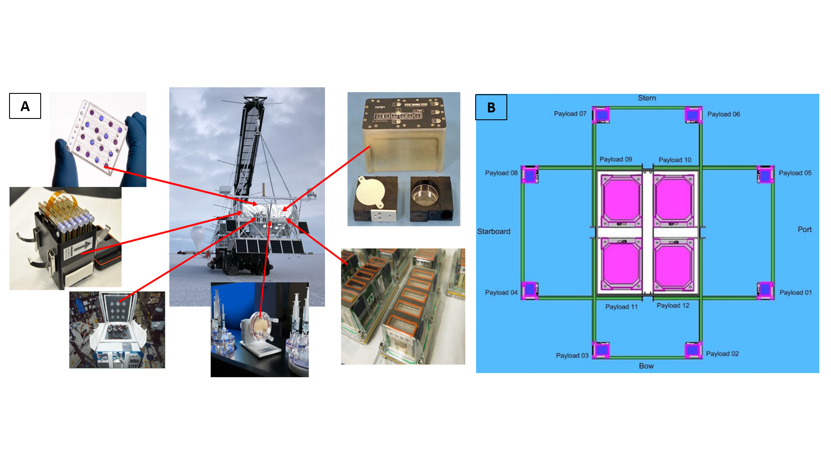

**Figure 4. (A)** A notional depiction of what an “omnibus” dedicated balloon mission for Space Biology, launched from Antarctica, with some representative hardware systems already used for ISS investigations; (B) Example from HASP [5] of a multi-payload balloon gondola (*top down* view of payload positions), with 4 large (*center*) and 8 small (*perimeter*) payloads.

1. **Conclusion**

Carrying 6,000 lbs of biological experiments into space to study GCR effects is not yet realistic. Nor is evaluating how biology responds to simulated low dose GCR in a ground-based facility like NSRL for 30+ days of uninterrupted beam time. Those are the constraints on Space Biology teams studying GCR radiation today, significantly diminishing the pace of progress and understanding.

**In contrast, Antarctic balloon missions flown by NASA provide a unique opportunity for access to** **~200 µGy/day, at dose rates & energy spectra comparable to deep space** [2]. Biological balloon hardware systems have already been proven, albeit on a small and limited scale as piggyback payloads. To enable a more sophisticated set of biology experiments flown from Antarctica, a dedicated “omnibus” mission is needed, one that could conceivably carry 8-12 Space Biology payloads sharing a common gondola. With SMD prioritization and a stepwise progression by the BPS Division, this opportunity can be realistically achieved, yielding space radiation results that will help guide NASA’s journey beyond low Earth orbit.

1. **References**
2. Smith DJ, Sowa MB. 2017. Ballooning for Biologists: Mission Essentials for Flying Life Science Experiments to Near Space on NASA Large Scientific Balloons. *Gravitational and Space Research* 5(1):52-73. DOI: <https://doi.org/10.2478/gsr-2017-0005>
3. Berger T, Matthiä D, Marsalek K, Przybyla B, Aeckerlein J, Rohde M, Wirtz M, Moeller R, James L, Lane M, Johnson P, Rauch B, Sowa M, Smith DJ. 2021 (in review). On the radiation environment during consecutive balloon flights over New Mexico and Antarctica. *Earth and Space Science Open Archive*. DOI: <https://doi.org/10.1002/essoar.10506355.1>
4. Cortesão M, Siems K, Koch S, Beblo-Vranesevic K, Rabbow E, Berger T, Lane M, James L, Johnson P, Waters S, Verma S, Smith DJ, Moeller R. 2021. MARSBOx: Fungal and bacterial endurance from a balloon-flown analog mission in the stratosphere. *Frontiers in Microbiology* 12(177). DOI: <https://doi.org/10.3389/fmicb.2021.601713>
5. Califar B, Tucker R, Cromie J, Sng N, Schmitz A, Callaham J, Barbazuk B, Paul A-L, Ferl RJ. 2020. Approaches for Surveying Cosmic Radiation Damage in Large Populations of Seeds – Antarctic Balloons and Particle Beams. *Gravitational and Space Research* 6(2):54-73. DOI: <https://doi.org/10.2478/gsr-2018-0010>
6. Guzik TG. 2015. The High Altitude Student Platform (HASP) as a model multi-payload balloon platform. *2015 IEEE Aerospace Conference*. pp. 1-10. DOI: <https://doi.org/10.1109/AERO.2015.7118985>
7. Smith DJ, Thakrar PJ, Bharrat AE, Dokos AG, Kinney TL, James LM, Lane MA, Khodadad CL, Maguire F, Maloney PR, Dawkins NL, 2014. A balloon-based payload for Exposing Microorganisms in the Stratosphere (E-MIST). *Gravitational and Space Research* 2(2):70-80. <http://gravitationalandspaceresearch.org/index.php/journal/article/view/661/693>