Auroral Currents: Student Guide

In this tutorial we will explore the magnetic effects of ***auroral currents***—currents in Earth’s ionosphere that are associated with the aurora (*e.g.,* the “Northern Lights”). We will find that we can model their behavior using what we know about the magnetic field caused by line currents.

## **Review: Line currents as sources of magnetic fields**

Imagine that you and a friend are studying magnetic fields by straight-line currents in a physics lab. You have started doing this by defining a coordinate system in which the directions of due north and due east—both parallel to your tabletop—are defined to be the + and + directions (that is, the +*x* and +*y* directions), respectively. (*Note:* In this section, ignore the effects of all sources of magnetic fields *other than* current-carrying wires.)

A. Which direction should you select for + (that is, the +*z* direction), so that your coordinate system is *right-handed?* Explain.

*Note:* Your answer here in part A may seem an odd choice, but we will see how this choice will be necessary when we examine real data about Earth’s magnetic field.

B. Now imagine that you begin your experiments by setting up a long, straight wire so that it is oriented horizontally, at a uniform height (say, 6.0 cm) above your lab table, and so that it carries a steady (conventional current) flowing in the – direction (westward). (See the perspective view diagram below left, and the side view diagram below right.)

Long current-carrying wire

Horizontal table

D

E

C

C

D

Current

For each of the following locations on the tabletop, determine whether each component of magnetic field *(Bx, By,* and *Bz)* due to the current-carrying wire are *positive, negative,* or *zero* at that location. Discuss your reasoning with your partners. (*Hint:* You should find one of these components to be equal to *zero* at all three locations. Which component, and why?)

* Location C: *Directly below* the wire (and hence, 6.0 cm directly beneath it)
* Location D: 8.0 cm *due north* of Location C
* Location E: 8.0 cm *due east* of Location C

## **Modeling currents associated with aurora**

The aurora is created by electric currents from space that flow along the magnetic field into and out of the ionosphere. These charged particles move horizontally through currents called the auroral electrojets.

Imagine now that you and your partners—working as physicists for the U.S. Geological Survey—are reviewing magnetic field data from the College, AK, observatory (near Fairbanks, AK) that were taken on a day (November 3, 2017) of a small magnetic disturbance that produced auroral electrojet activity. The zero level in the plot below refers to the undisturbed magnetic field, so that deviations from zero in the magnetic field are due to the electrojets.[1]

*Note:* The (right-handed) coordinate system used for these data is defined just as you have been using thus far in this tutorial: + points due north and + points due east. For our purposes, we will use only the data displayed in the first three graphs—for *Bx, By,* and *Bz* , respectively. The time (horizontal axis) is given in Universal Time (UT), which is also Greenwich Mean Time (GMT).

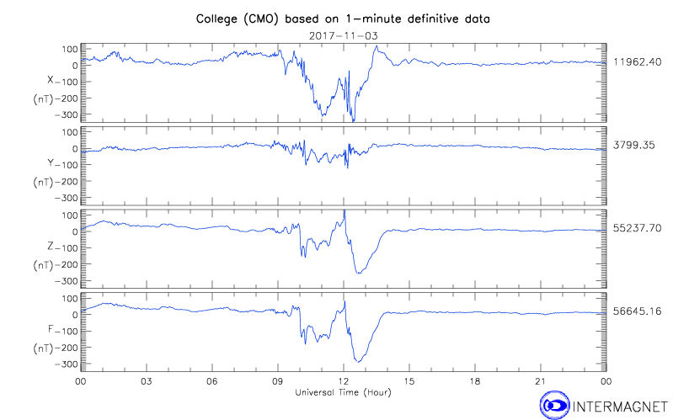

A. With your partners, explain how you can make sense of the magnetic field data at 1230 UT by approximating the auroral current as a line current running along a *west-east line* in the ionosophere near the observatory. Was the current (modeled as a conventional line current) running *west* or *east?*

B. You can make your results from part A more quantitative by using the plot below, which runs from 1000 UT to 1400 UT. Assuming that the auroral current can be modeled as a line current running through the ionosphere, at an approximate altitude of 100 km above the earth’s surface, deduce the following information about the current that was present at 1230 UT:

* Explain with your partners how you can tell that at 1230 UT the line current was **not** running *directly above* the CMO observatory. Was it instead *due north* or *due south* of the observatory?
* How far due *north* or due *south* (in km) was the line current?

* What was the (approximate) *value* of the current? (You may wish to use *μo* = 4π × 102 nT·m/A.)   
    
  (*Note:* Although the data below are plotted in nT, you should find the current to be rather impressive in size! If this had been a stronger magnetic disturbance—for which the perturbation to the magnetic field could reach as high as 2,000 nT—the current responsible for such a field would be approximately *one million* amperes.)

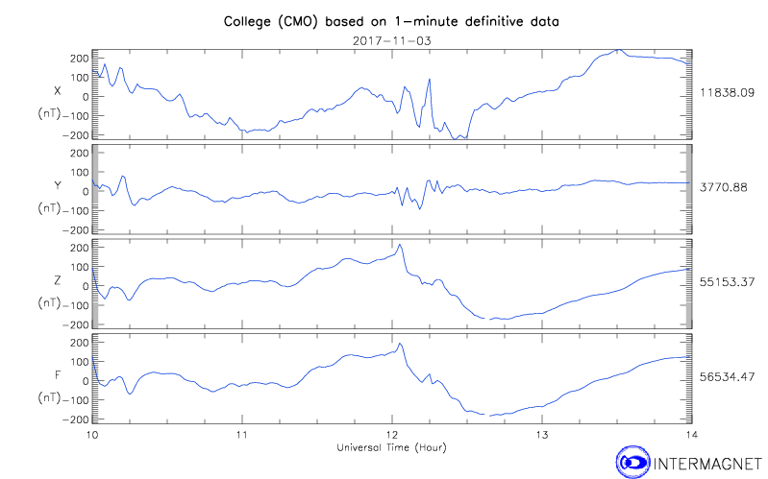

1. Data provided by the International Real-time Magnetic Observatory Network, [www.intermagnet.org](http://www.intermagnet.org)