**Plant Maze Experiment**

Plants tend to grow and stretch toward a source of light, like the Sun. This phenomenon is known as phototropism. The following experiment demonstrates how a plant will even move around obstacles to find its way to the light.

Materials:

* A large shoe box with a lid or other cardboard box that you can open and close
* Two pieces of cardboard
* A small flowerpot or other container filled with potting soil
* 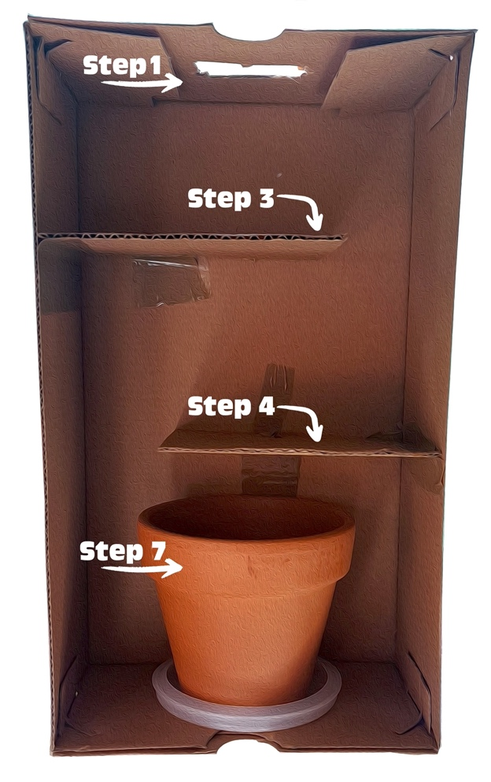Lima bean, pole bean, or pea seeds
* A lamp or a window with access to sunlight
* Strong tape
* Scissors that can cut the cardboard and box

Steps:

1. Cut a square or round hole about 2 inches across in one of the smaller sides of the box. (Ask an adult for help.)
2. Cut two pieces of cardboard so they’re about two-thirds as long as the small side of the box and the same depth as the box. (You want these pieces to be able to fit inside the box like a shelf that doesn’t reach all the way across.)
3. Tape one piece of cardboard to the inside of the box a few inches away from and parallel to the end of the box with the hole. One edge of the cardboard that is the same depth as the box should be taped to one of the long sides of the box, and an adjacent edge should be flat against the bottom of the box.
4. Tape the other piece of cardboard to the inside of the box in the same way, but against the other long side of the box and closer to the end of the box without the hole. Leave enough space for the flowerpot to fit inside that space between the cardboard piece and the small end of the box.
5. Stand the box on a sunny windowsill or underneath a lamp so that the end with the hole is at the top near the light.
6. Plant two or three seeds in the pot, about 1 inch deep in the soil. Water the soil.
7. Place the pot in the bottom of the box. (If the pot has a drainage hole, place something underneath it to catch water so the box doesn’t get wet.)
8. Close the box. Make sure no light can get in other than through the hole at the top.
9. Open the box once per day to water the plant and check its progress.
10. Over a few weeks, watch to see whether the plant grows and navigates around the carboard obstacles you placed in the box to move toward the light. Optional: Take a photo each day to document its progress.